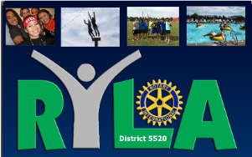

For Immediate Release
For More Information Contact:

Name:

Telephone:
Email:

The Rotary Club of ____________ is searching for candidates to attend its annual District 5520 Rotary Youth Leadership Camp (RYLA) at Manzano Mountain Retreat, near Mountainair, NM this summer. The boy’s camp is Sunday, July 16 to Saturday July 22, 2017, and the girl’s camp is Saturday, July 22 to Friday, July 28, 2017.

__________, local RYLA committee chairperson, said that participants will be selected from young men and women who have exhibited leadership abilities and who will be entering their senior year of high school in the fall. The Rotary Club is in the process of contacting high school principals, guidance counselors, youth organizations, and other sources for nominations of RYLA participants.

Aimed at developing the leadership potential of young men and women, RYLA will feature many challenging activities including workshops, speakers, discussions, sports, music, and news reporting. Topics will focus on decision-making, critical thinking, communicating effectively, ethics, public service, contemporary problems, and career development.

The participants will live, work, study, and play together in a democratic setting under the guidance of experienced counselors and educators. In addition, guest lecturers and discussion leaders will present a wide variety of vocational and community interests.

Anyone interested in obtaining further information should contact:

Telephone:

Email:

or any other member of the Rotary Club.

Visit the following website for additional information: www.rotary5520.org under New Generations (Youth Services) under RYLA

