FOOD FEST 2024 – SEA CREATURES COME ASHORE
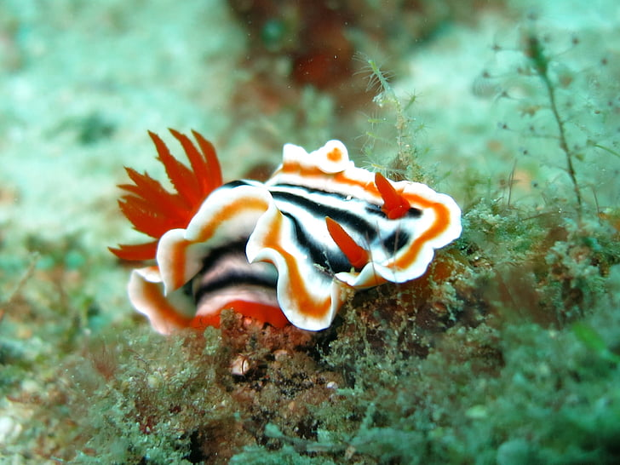
FRIDAY, MAY 3, 2024 DEADLINE TO REGISTER:
Point Cadet Plaza, Biloxi APRIL 22, 2024

- NOTE – CONFERENCE REGISTRATION IS NOW REQUIRED FOR ALL ROTARIANS WHO ATTENDS FOOD FEST. A CLUB THAT PARTICIPATES IN FOOD FEST WILL BE GIVEN FOUR FREE WRISTBANDS TO COVER THEIR COOKING/SERVING TEAM. WE WILL ONLY DISTRIBUTE THE FOUR WRISTBANDS TO THE PERSON LISTED BELOW AS YOUR CLUB’S REPRESENTATIVE. ALL CLUB WRISTBANDS WILL BE AVAILABLE AT THE FOOD FEST SITE. NOTE: NON-ROTARIAN SPOUSE/PARTNER OR CHILDREN DO NOT NEED TO REGISTER WHEN ROTARIAN SPOUSE IS REGISTERED. REGISTER EARLY AS REGISTRATION FEES GO UP AS WE GET CLOSER TO THE CONFERENCE.
Club Name______________________________________Club Representative__________________________________
Contact Phone______________________________ Print Contact Email_______________________________________
Food/Drink being served___________________________________________________________________________
We are expecting 250-350 in attendance at the Food Fest.
Do you need electricity?______________________ Do you need to be close to water?______________________
- Setup begins at 2:00 p.m. Please do not arrive early as we need time to set up the space.
- Please plan on your food service to begin at 5:30 p.m.
- You will have at least one 6 foot table and two chairs.
- We ask that you bring all items necessary to cook and serve your food.
- We ask that you bring any paper products or serving utensils you will need.
- We ask that your club cleans your cooking and serving area at the end of the night.
- Trash bags will be provided. Ice will be provided.
- We ask that you bring any needed extension cords, buckets, water hoses, or cookware that you need.
- We ask that you decorate your table in a way that will showcase your favorite sea creature. There are thousands out there! (See Food Fest Flyer for more info on table decorating contest.)
There will be a prize for the best table decorations.
- There will be amble parking and seating at Point Cadet.
This form will register your club. You will need to register member attendance on the Conference Registration Form.
Please return this completed form to: KSPRINGER@UNITEDWAYSM.ORG

When your form is received you will be sent a confirmation email. If you do not receive a confirmation then we didn’t receive your form.

