FOOD FEST 2024
SEA CREATURES COME ASHORE
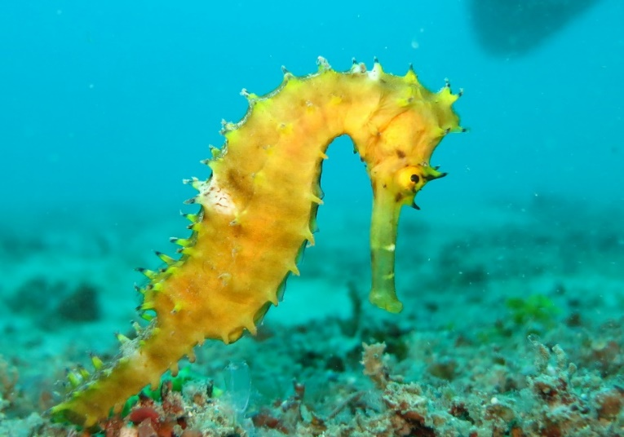
We ask that you decorate your table in a way that will showcase your favorite sea creature. There are thousands out there!
REAL OR IMAGINED
Prize for top FIVE table decorations!
POINT CADET PLAZA
BILOXI, MISSISSIPPI
FRIDAY, MAY 3, 2024

Contact District Food Fest Chair for more info and to register your club:
Food Fest Chair – Kathy Springer, Edgewater Rotary
Email: kspringer@unitedway.org

REGISTER EARLY FOR THE CONFERENCE, AS REGISTRATION FEES GO UP AS WE GET CLOSER TO THE CONFERENCE.

