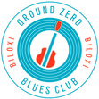

Ground Zero Blues Club
(Owner Morgan Freeman).
Watch the chef prepare your local seafood meal and then enjoy!

Thursday, May 2, 2024
11:00 am
Limited to 30 participants.

(This event is currently tentative as we try and nail down the venue. In case of venue cancellation or change all registered will have an
option to have fees refunded.)

