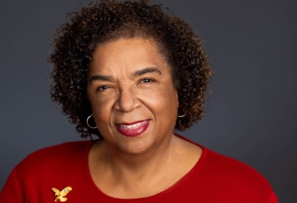

Dianne Crawford
Dianne Crawford is an accomplished Rotary leader with a distinguished record of service and leadership. She joined Rotary in 1997 and is a proud member of the Rotary Club of Southeast San Diego, where she has served as President, Secretary, and Board Member. For more than 50 years, her club has addressed the needs of underserved communities in Southeast San Diego, consistently earning the Rotary Citation for excellence. Dianne’s passion for education is reflected in her deep involvement with youth leadership development programs such as RYLA, LEAD, and Interact, all of which prepare and inspire the next generation of leaders.
Professionally, Dianne built a 25-year career as Director of Sales for national telecommunications companies and later with Language Line Services, the largest provider of interpretation services in the United States. There, she managed national account teams and Fortune 100 clients including American Express, Bank of America, AT&T, Microsoft, Citibank, and Amazon. Today, she serves as a Sales & Management Consultant, offering expertise in business development, customer engagement, organizational planning, and training.
Within Rotary District 5340, Dianne has contributed more than two decades of service on the Leadership Team. Her roles have included Assistant Governor, Membership Chair, Strategic Planning Chair, New Club Development Chair, and facilitator for both the Rotary Leadership Institute and President-Elect Training. Her strategic vision, creativity, and hands-on leadership have enhanced district operations, strengthened clubs, and inspired membership growth. She has served on the leadership team for every District Governor since 2006. In recognition of her impact, she has received numerous awards, including 2010/2011 Rotarian of the Year.
Currently serving as District Governor for Rotary District 5340 in 2024–2025, Dianne leads one of the largest and most successful districts in Rotary International. Embracing this year’s theme, The Magic of Rotary, she is committed to helping members create meaningful change, expand service, and spread Rotary’s magic throughout their communities.
Dianne resides in San Diego, California, with her husband Michael. She treasures time with her son, Regis, and grandson, Kingston, and enjoys visiting her family on the beautiful island of St. Martin in the Caribbean.

