Past District Governor’s Biographical Form:
Name
Date: District 5340 Governor yyyy-yy
Rotary Biographical Information (230-250 Words)

Attache Photo

Example of a completed form:
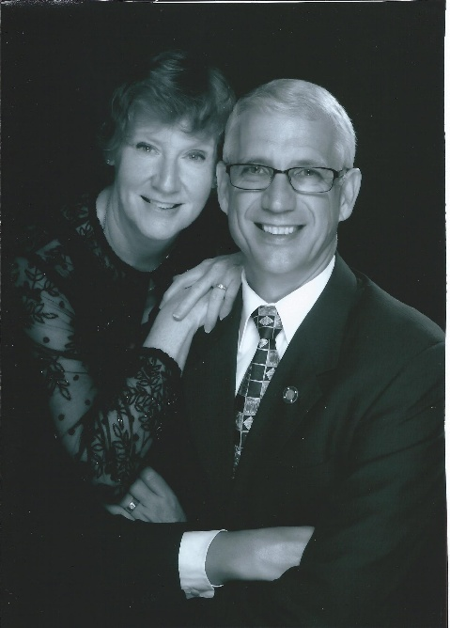
Don Fipps
District 5340 Governor 2023-24
Don Fipps has been a Rotarian for 17 years and is a member of the Rotary Club of Del Mar where he was president 2018-19. Don had been an Assistant Governor 2019-2021 and Chief Aide to Rotary District 5340 Governor Dan Gensler 2021-22. Del Mar is Don’s third Rotary Club, he was also a member of the Rotary Clubs of Wilkes-Barre, PA and West Sacramento, CA.
Don is a native Californian born in Bakersfield. He attended California Polytechnical State University in San Luis Obispo majoring in Biochemistry and graduated in 1977 and was subsequently commissioned in the United States Army through ROTC. Don retired from the Army in 1997 as Lieutenant Colonel in the Medical Services Corps. He also has an MS in Biology from Bowling Green State University. After working for the American Red Cross in several locations, an independent blood center in Sacramento and finally the University of California San Diego Health, Don retired in 2018.
Don married Donna McIlwain in 1975 after meeting at Cal Poly. Don and Donna have 2 children, Aaron married to Colleen with 2 children Burnie and Ben; and April, married to Ray with 2 children Charlie and Caroline. They raise Canine Companions service dog puppies.
Don is a Paul Harris Fellow plus 6 and a member of the Paul Harris Society, Don and Donna, also a member of the Rotary Club of Del Mar, are level 4 Bequest Society members and level 1 Major Donors.

