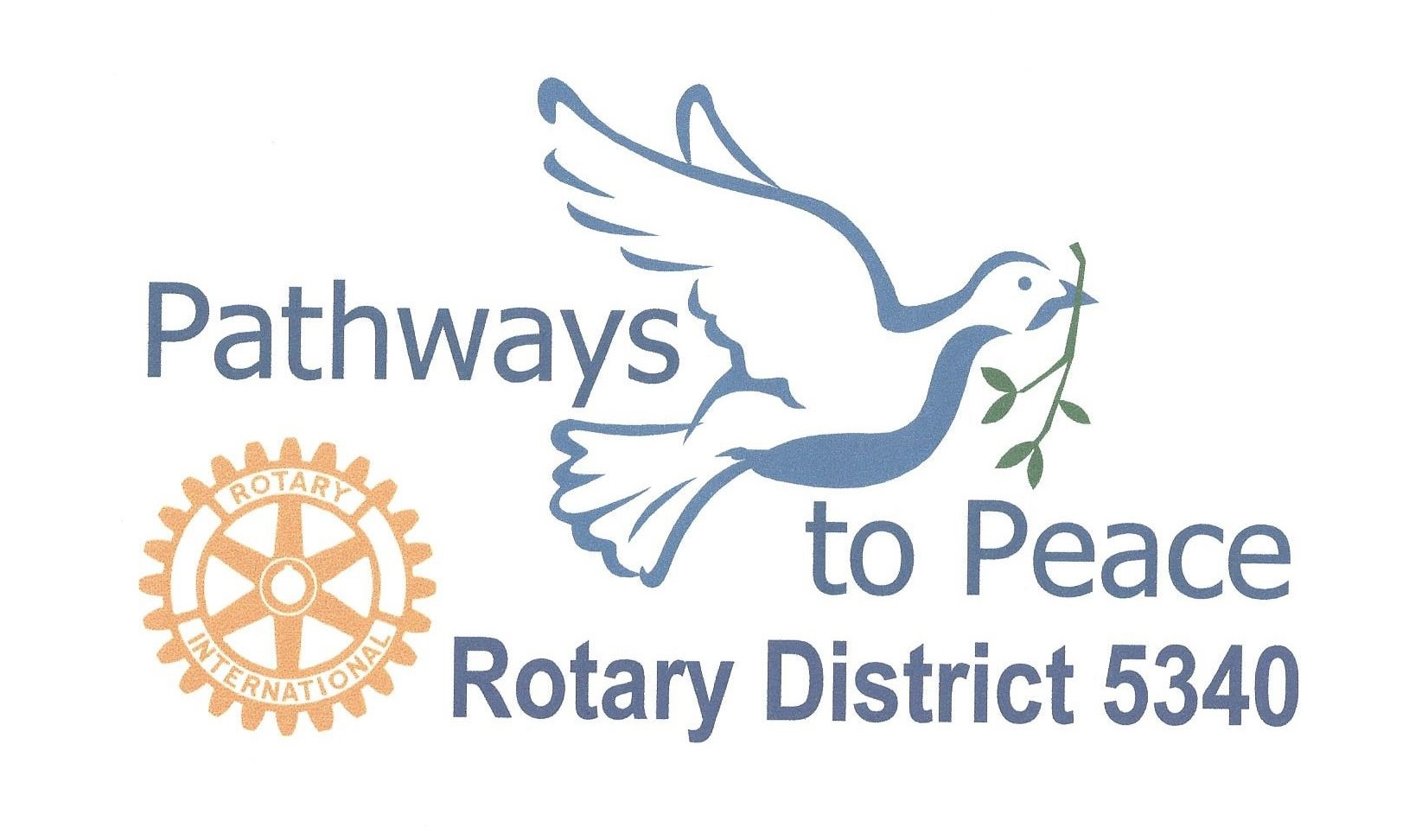

Peace Leadership Seminar

Sponsored by District 5340 Pathways to Peace Committee, this seminar is for club Peace Chairs, Rotaract, Ineract and for those with an interest in Rotary’s peace initiatives and how Rotary is working to become an ever-greater force for peace at home and throughout the world.
When: Saturday, September 16, 2017 9:00am – 12:30pm
Where: Ronald McDonald House
2929 Children’s Way, San Diego, 92123
Ample free parking in the garage on the east side of Children’s Way, across the street from Rady Children’s Hospital.

Register on District Website: www. Rotary5340.org
(Event is free, but we request registration for planning.)
For Information : Sandra Schrift (sandra@schrift.com)
Prepare for Peace Programs for Rotary Year 2017-18
- Peace Leadership Seminar (September 16, 2017)
- Pathways to Peace Award @ Foundation Seminar (September 23, 2017)
- World Understanding Month (February 2018)
- Presidential Peacebuilding Conference (Vancouver) (February 10, 2018)
- District 5340 Peace Forum (February 24, 2018)
- Rotary Model United Nations (April 7-8, 2018)
- Select Peace Fellow Candidates/Rotary Peace Centers (June 2018)
- Club Peacemaker Awards (throughout year)
Featuring
An Overview of District 5340 Pathways to Peace
Learn about the club Peace Chair role and Peace Programs in Your Club

Learn How Rotary Service Promotes Peace

