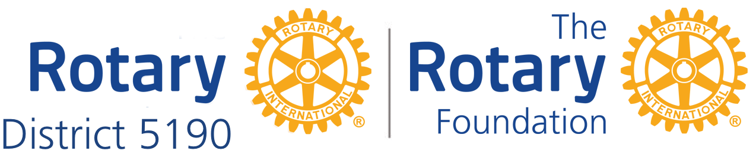

DISTRICT 5190 SMILES WITHOUT BORDERS
District Grant Project

An international project of the Rotary clubs of District 5190

The project includes the purchase and installation of operating room lights for the 1000 Smiles Foundation operating theatre in Ensenada Mexico, as well as a hearing test booth and hands-on support for a cleft palate clinic.

CLUB CONTRIBUTION
1) Club Name
2) Pay by mail | $300 (enough if all clubs participate)  $500 (that still works)  $1,000  $2,000
3) Contact person in your club
4) Contact’s e-mail
5) Is this a grant? | Yes. A District sponsored District Service Grant funded with District Block Grant funds and Club contributions.
6) Project’s International Primary Contact Club? | Nevada City 49er Breakfast Rotary
7) Send check by e-mail or paper mail | Address/Contact Information Below
8) Send to: | D5190 Smiles Without Borders  c/o Nevada City 49er Rotary  101 W. McKnight Way, #B  Grass Valley, CA 95949  Check made out to: “D5190/NC49er Smiles Without Borders”
9) Project Dates? | Start: In Progress Finish: March 31, 2019
10) Questions?  International Primary Contact | E-mail: Barry Turner: baturner@nccn.net  Phone: (530) 272-8525

NOTE: This important project will change the lives of these young patients. Absolutely, that is the main focus of the project. It is important to notice that small, medium, and/or large clubs can be partners in Global Grant-sized projects.

