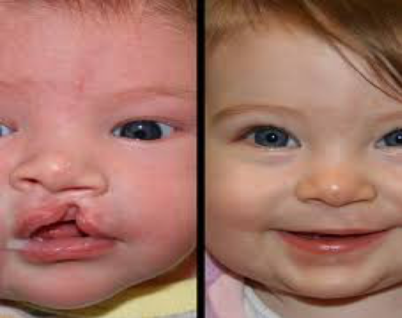
WHO?

Every Mexican child whose cleft lip and/or palate still needs a simple 45-minute $240 surgery
WHAT?

Two sets of overhead operating room lights for newly added surgicenter

ROTARY DISTRICT 5190

SMILES WITHOUT BORDERS

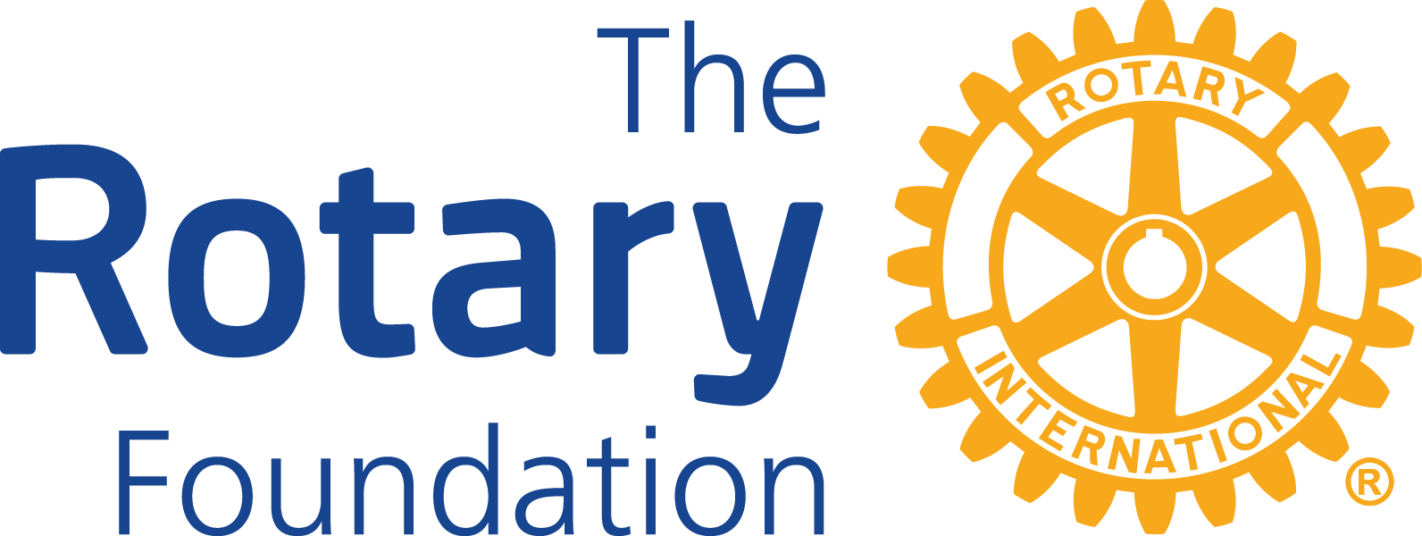

D5190 Rotary Clubs have been working with the San Diego area Rotary clubs for over 20 years at their Thousand Smiles Foundation dental clinic in Ensenada. New surgical suites have been added to the existing clinics. Owning their own surgical facility will make it possible to offer more surgeries. Providing new operating room lights will be part of this project. Historically, there have been more cleft patients than there are operating tables and surgeons. We want to eliminate the waiting list. 50 clubs giving $300 each would pay for both operating room lights. This is a great way for small clubs to participate in a large Grant project. Send contributions (checks) by snail mail to:
WHERE?

1000 Smiles Rotary Dental Clinic in Ensenada, Mexico
D5190/NC49er Smiles Without Borders
WHEN?

Start: 7/1/2018
Finish: 3/31/2019

Pledge now. Pay later
C/O Nevada City 49er Rotary
101 W. McKnight Way, #B
Grass Valley, CA 95949

“Hands-on” weekends: Feb. 1 & 2 or March 1 & 2 (ribbon cutting grand openings). Fly to San Diego, bus to Ensenada. Two nights in Ensenada. The focus is on the life-changing cleft surgeries for kids. Any club can qualify (international).

Questions? E-mail: Barry Turner at baturner@nccn.net

