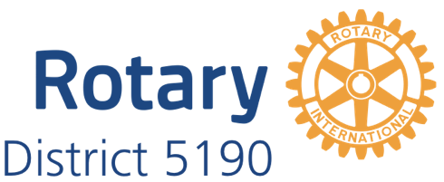

ROTARY DISTRICT 5190 2020 YOUTH INSTRUMENTAL MUSIC CONTEST
Area Winner’s Name Submission

Area Chair: Please submit the name of the winner of your area level contest to compete at the D5190 Finals at 2:00 pm, Saturday, April 25, 2020 at the Nugget in Sparks, NV. Area winners must be prepared, if they win the district conference, to perform at the Saturday evening dinner.
Please complete this form and return to the District Music Contest Chair, Clark Kent, by April 15, 2020. Email to denniskent@sbcglobal.net or mail to 5335 Twin Creeks Drive Reno, NV 89523. Please provide your contestant with the district contest information. You will be their main point of contact. Receipt deadline of April 15, 2020, is necessary for subsequent communication of district contest information to all area winners. Thank you for your cooperation with this deadline.
As Area # ______ Chair, I have reviewed the contest rules (See second page of this document). The clubs in my area agree to abide by the rules and by the decision of the judges.
Our area winner is ____________________________________________(please print).
Sponsored by the Rotary Club of ___________________________________________.
Grade/Age__________ High School__________________________________________
His/her instrument is ______________________________________________________.
Winner’s Cell Phone________________________Email_________________________________

Area Music Contest Chair Printed Name: _____________________________________________
Signed: _____________________________________

Address: _____________________________________________
Email: _______________________________________________
Cell Phone: _______________________________________________
Music Contest Rules
The purpose of this competition is to determine the solo/individual musician who best demonstrates his/her musical talent and love for music. Prize money will be awarded at each level of competition: Rotary Club, Rotary Area, and the Rotary District 5190 Final Contest.
If you win a local Rotary Club Contest and then an Area Contest, you will be able to compete at the Rotary District 5190 Finals. The final competition will be held at 2:00 pm Saturday, April 25, 2020, at the Nugget in Sparks. The prizes will be $1,000 for First Place, $750 for Second Place, and $500 for Third Place.
Rules
- You must be a high school student (grades 9-12) in a school located in District 5190 or a
home-schooled/non-traditionally schooled student 14 to 18 years of age in that area.
- You must be sponsored by a District 5190 Rotary Club.
        - Performance time will be 3 minutes minimum to 8 minute maximum, with strict penalties for under or over time.
- If you win at any level, you must be able to attend and compete in the next level of
competition to be eligible for prize money.
- You will be responsible for any subsequent travel expense.
- You must bring 4 copies of your music for the judges.
- All decisions by the judges are final and are based on musical ability, musical empathy,
musical sound, musical selection, and stage presence
- A winner of a previous District Final is not eligible to compete again.
- YOU MAY ONLY COMPETE IN ONE CLUB CONTEST EACH YEAR!
- THIS IS A SOLO/INDIVIDUAL COMPETITION: You will be responsible for an
  - accompaniment, if needed, but only your performance will be graded.

I have read the above rules and agree to abide by them and by the decision of the judges.
Printed Name: ______________________________________Signed: __________________________
Instrument: ____________________ Grade/Age_______ High School_____________________________
Parent/Guardian signature: ____________________________________
Address: _____________________________________________ Cell Phone: __________________
E-mail:____________________________ Rotary Area # _______
Sponsoring Rotary Club ____________________________________________________________

