**Literacy Success for Kids!**

**Free literacy resources for Pre-K/Kindergarten**

|  |  |  |  |  |
| --- | --- | --- | --- | --- |
| C:\Users\LDWic\OneDrive\Documents\I can read complete\Logos and Cover Picture\logo molly colored\IcanReadSongs-Logo.jpg  **Videos on YouTube** | | **A Rotary Literacy Gift** | [http://tbn0.google.com/images?q=tbn:-Ebcl68X5C9s6M:http://www.darienrotaryclub.org/Images/Rotary%2520Emblem.jpg](http://images.google.com/imgres?imgurl=http://www.darienrotaryclub.org/Images/Rotary%20Emblem.jpg&imgrefurl=http://www.darienrotaryclub.org/&h=218&w=218&sz=18&hl=en&start=1&tbnid=-Ebcl68X5C9s6M:&tbnh=107&tbnw=107&prev=/images?q%3Drotary%2Bclub%2Bemblem%26gbv%3D2%26svnum%3D10%26hl%3Den%26sa%3DG) | |
|  | |  |  | | --- | --- | |  |  | | | |

**Teach sight words: I, we, go, see, like, the, can, you, my, in, on, to, and**

**Free Teaching Videos** at: [www.youtube.com/icanreadsongs](http://www.youtube.com/icanreadsongs)

|  |  |  |
| --- | --- | --- |
|  | Picture 11 | C:\Users\LaDonna\Pictures\Smart Board Kids.jpg |

**Free Literacy Resources** at: [www.icanreadsongs.org](http://www.icanreadsongs.org)

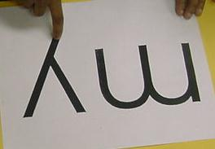 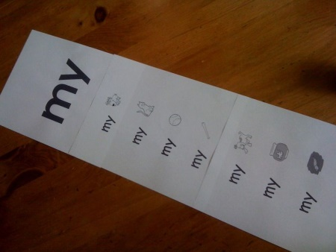 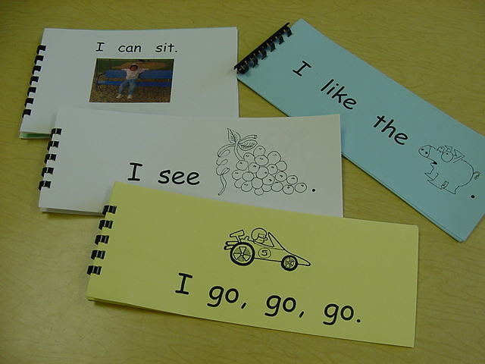

I Can Read Inc. 1826 Brown Deer Cove, Coralville, IA 52241 [info@Icanreadsongs.org](mailto:info@Icanreadsongs.org), 319-351-1445

|  |  |
| --- | --- |
| [http://tbn0.google.com/images?q=tbn:-Ebcl68X5C9s6M:http://www.darienrotaryclub.org/Images/Rotary%2520Emblem.jpg](http://images.google.com/imgres?imgurl=http://www.darienrotaryclub.org/Images/Rotary%20Emblem.jpg&imgrefurl=http://www.darienrotaryclub.org/&h=218&w=218&sz=18&hl=en&start=1&tbnid=-Ebcl68X5C9s6M:&tbnh=107&tbnw=107&prev=/images?q%3Drotary%2Bclub%2Bemblem%26gbv%3D2%26svnum%3D10%26hl%3Den%26sa%3DG) | C:\Users\LDWic\OneDrive\Documents\I can read complete\Logos and Cover Picture\logo molly colored\IcanReadSongs-Logo.jpg |

**Options for gifting to your Pre-K or Kindergarten:**

|  |  |  |
| --- | --- | --- |
| **TEACHER SET**  Activity Book, CD of Songs, and Charts  C:\Users\LDWic\AppData\Local\Temp\Temp1_ICanReadSongscvrjpegs.zip\I-can-Read-Songs-cvr-md.jpg  Sing Along and2  Just $25 per teacher | **PARENT DVDS**  Video with sing-along, dance along literacy fun.  **C:\Users\LDWic\OneDrive\Pictures\Family DVD and Brochure image.jpg**  Just $3 per family | **ENGLISH/SPANISH** Activity Book with DVD  C:\Users\LaDonna\Documents\Spanishcover2\14-46-I-can-Read-Songs-Spanish-frnt-cvr.jpg  Just $7 on orders of 10 or more. |

**Start a Rotary literacy project. Get an order form at:**

[**info@Icanreadsongs.org**](mailto:info@Icanreadsongs.org) **or**

**call LaDonna Wicklund at 319-351-1445**

I Can Read, Inc., 1826 Brown Deer Cove, Coralville, IA [info@icanreadsongs.org](mailto:info@icanreadsongs.org) 319-351-1445 LaDonna Wicklund