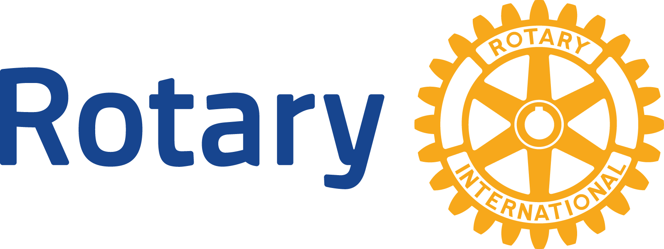
ENGLISH (EN)

Eradicating polio
the need

Although it currently circulates in only a few countries, polio is highly infectious and spreads rapidly. The disease, which afflicts mainly children, is transmitted via contaminated water and food supplies. Five to 10 percent of cases are fatal. As long as polio threatens even one child anywhere in the world, children everywhere are at risk. Only the global eradication of polio will ensure that no child ever again suffers its devastating effects.
Where we are today
- Since Rotary launched PolioPlus in 1985, polio has decreased by 99.9 percent.
- Rotary and its partners have reduced the number of polio cases from 350,000 in 1985 to 37 in 2016.
- Only three countries continue to record low-level transmission of the wild poliovirus: Afghanistan, Pakistan and Nigeria.
- Wild poliovirus type 1 continues to cause cases of paralysis. Type 2 was certified as eradicated in September 2015, and no cases of type 3 have been reported since November 2012.
Rotary’s role
Rotary had the vision “to immunize all of the world’s children against polio” with the creation of PolioPlus in 1985. The goal expanded to eradicating the disease in 1988, when the World Health Assembly (the governing body of the World Health Organization [WHO]) resolved to end polio. Toward that goal, Rotary helped assemble the partnerships with WHO, UNICEF, and the U.S. Centers for Disease Control and Prevention that established the Global Polio Eradication Initiative (GPEI).
Rotary is a leading partner in the GPEI, which also includes the Bill & Melinda Gates Foundation. Rotarians raise funds; secure support from governments, nongovernmental organizations, corporations, and the public; immunize children; and promote awareness in their communities.
Rotary has helped immunize more than 2.5 billion children against polio, contributed over $1.7 billion to global polio eradication efforts, and helped secure more than $8 billion from donor governments.
How we will eradicate polio
The GPEI is working to interrupt transmission of the wild poliovirus through:
- Routine immunization coverage of more than 80 percent of children in their first year of life. This requires at least three doses of the oral polio vaccine as part of national immunization schedules.
- Supplementary immunization activities, including National Immunization Days, to immunize children under 5 with two doses of oral polio vaccine.
- Surveillance (identification and prompt reporting) by health workers of every case of acute flaccid paralysis (sudden weakness that may be caused by the poliovirus), as well as surveillance of sewage water in the environment for poliovirus that has not yet caused infections.
- Targeted mop-up campaigns where the poliovirus is known or thought to be present.
Where we are headed
With full commitment and sufficient financial resources, we have an extraordinary opportunity to end polio for good. Although progress against polio is being made in many parts of the world, there is still hard work ahead to achieve eradication. Pakistan, Afghanistan, and Nigeria require the support of Rotary and the global community to ensure that political commitment and quality programs are in place to ensure that every child, particularly those in the most marginalized communities who are persistently missed, is vaccinated.
Until polio is eradicated, all countries must remain vigilant. As long as the wild poliovirus circulates in Pakistan, Afghanistan, and Nigeria, the risk of the disease’s global spread remains high. Outbreaks can be stopped, however, as seen in the effective response to reported cases found across the Horn of Africa and the Middle East in 2013 and 2014.
How Rotary’s contributions are spent
Through PolioPlus, Rotary initially paid for oral polio vaccine and start-up costs for Rotarians’ social mobilization efforts in endemic countries. Rotary now funds operational needs, technical advisers’ salaries, surveillance, social mobilization, stipends for millions of volunteers who conduct National Immunization Days and house-to-house follow-up visits, and research on ways to facilitate eradication.
What polio eradication will cost
At Rotary’s 2017 International Convention in Atlanta, global leaders pledged $1.2 billion to the fight to eradicate polio. However, Rotary’s work continues: both to ensure world governments make good on their pledges, and also to raise the new funds to ensure we reach every child with the vaccine. Rotary is committed to raising $50 million per year over the next three years as part of the End Polio Now: Countdown to History campaign. Under an expanded partnership with the Bill & Melinda Gates Foundation, every $1 Rotary commits to polio eradication will be matched 2-to-1 (up to $ 50 million per year).
How you can help
Rotarians can take action to hold fundraisers, raise public awareness, write their government representatives, donate, share stories, and encourage others to join our cause.
Rotary’s legacy
Polio eradication, once certified, will generate substantial humanitarian and financial dividends due to the end of polio treatment and rehabilitation costs. A Vaccine journal study in 2010 estimates the economic benefits of polio eradication at $40 billion to $50 billion, which could help fund other public health priorities. Rotarians are already supporting some of them as part of PolioPlus, such as immunizing children against measles, distributing vitamin A supplements and bed nets to prevent malaria, and providing clean water. The polio surveillance network in Nigeria helped the government stop the Ebola outbreak in 2014.
Find out more
Learn more about our polio eradication efforts at endpolio.org.
The Secretariat’s key experts on eradicating polio are:
- PolioPlus Director Carol Pandak
- PolioPlus Advocacy Specialist Kris Tsau
- PolioPlus Senior Coordinator Amy Edwards
Send questions about fundraising to PolioPlus Fundraising Specialist Clare Monroe.
Send questions about communications to PolioPlus Communications Senior Specialist Michelle Kloempken.

