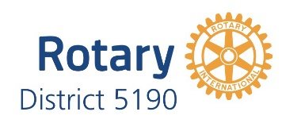 | District 5190  Rotary Academy

REGISTRATION FORM

The Rotary Academy is a comprehensive study program of Rotary information for those who aspire to leadership positions within their club or district, but all Rotarians are encouraged to take the course. The curriculum consists of ten correspondence lessons. Further information will be sent to students as registration forms are received.

NAME

ADDRESS

CITY ZIP

TELEPHONE ____ FAX_______

EMAIL

ROTARY CLUB

MAIL COMPLETED REGISTRATION FORM TO

Karen Grosz
739 Coughlin Glen
Reno, Nevada 89519
530-310-6650
Email: kgrosz5190@gmail.com

