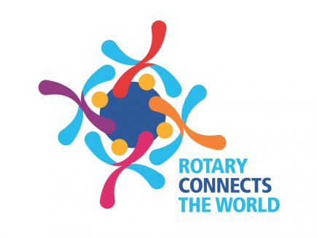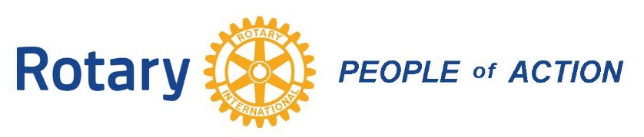
April 21, 2020
Dear Club Presidents, Club Presidents-Elect and Club Foundation Chairpersons;
For your immediate information and action!
District 7150 Rotary Clubs can now apply for reimbursement of Club expenses for local COVID-19 pandemic response projects that have been initiated since March 15, 2020. We have two (2) new sources of grant funds for reimbursing your Club purchases made to help support local first responders with supplies, meal plans or backpack programs for students, hygiene supplies for healthcare essential workers, facemasks for hospital employees, local food bank purchases, etc. These local needs are ongoing and real, and our Clubs are finding new ways to help.`
1. District Designated Funds (DDF) of $11,000.00 are now available on a first-come, first served basis, maximum of $1,000.00 per Club. These funds must be used by no later than May 30, 2020.
  - Complete the COVID-19 Response Fund form shown on the next page. It must be signed by a current Club Officer.
  - Provide copies of receipts for the items purchased, an Invoice of the items from the provider, and a copy of your Club’s cancelled check. These reimbursement requests will be reviewed by our District Foundation Committee. Each Club must still adhere to the Rotary Foundation Grant guidelines. If your project is approved, there will be some additional paperwork necessary, and we will help you with that. Also, if a Club is purchasing items from a private company over $50 in value, there must be competitive bids or comparative pricing shown, even if their money is already spent.
  - NO Club matching share is required! NO Grant Training attendance required!
2. District 7150 COVID-19 Response Funds currently at $10,000 and growing, are privately raised from District Leaders and re-allocated surpluses from the 2019-2020 District Budget. They are independent of the Foundation, and are available for Club project reimbursement as well. These funds can be used now, and beyond May 30, 2020.
  - Complete the COVID-19 Response Fund form shown on the next page. It must be signed by a current Club Officer.
  - Provide description of the project, provide receipts available from purchases by individual Rotarians or by the Club. These expenses will be reviewed by a group of District Rotarians. On-going weekly or monthly projects by Clubs can be submitted for consideration.
  - NO Club matching share is required! NO Grant Training attendance required!
To keep this process as simplified as possible, we are using the report form shown on the next page for all reimbursement requests. Please note that all documents go to DGND Dana Jerrard, via e-mail whenever possible!
Please remember, the regular 2020-2021 District Grant process is also still in place for Clubs to request matching funds for projects that will occur in the future. Those applications must be submitted by June 1, 2020.
Yours in Rotary Service,
DG Randy Wilson 2019-2020
Stay Safe, Stay Healthy, Stay Connected!
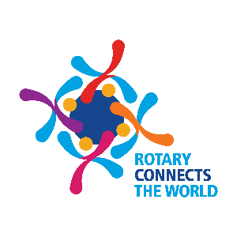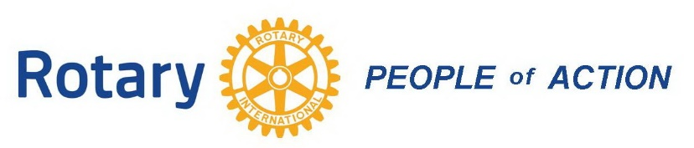
Rotary District 7150
COVID-19 Response Grant Application Form
Please submit this report page by Friday, May 1, 2020, with copies of receipts and payments made for COVID-19 Response purchases made by your Rotary Club and members to help support local First Responders, meal plans, healthcare essential workers, local food banks, etc. Please keep in mind that reimbursement may come from either the District COVID-19 Response Fund or from District Designated Funds from our Rotary Foundation contributions.

- Sponsoring Rotary Club: __________________________________
- Support provided to: __________________________________________
- Amount of local Rotary Club Funds spent: ____________________________
(Please attach copies of receipts, payment checks, etc.)
- COVID-19 Response Fund amount requested: ___________________________
- Describe the project. Briefly explain the local community essential business or workers who benefited from the Rotary Club’s COVID-19 inspired project. (Please attach separate sheet.)
2019-20 Club President_______________________________________________________
Signature____________________________________ Date_____________________
2020-21 Club President_____________________________________________
Signature____________________________________ Date______________________
Email this form and attachments to Dana Jerrard, Rotary Club of Utica, at jerrarddana@gmail.com or mail to 32 Ironwood Road, New Hartford, NY 13413

