`
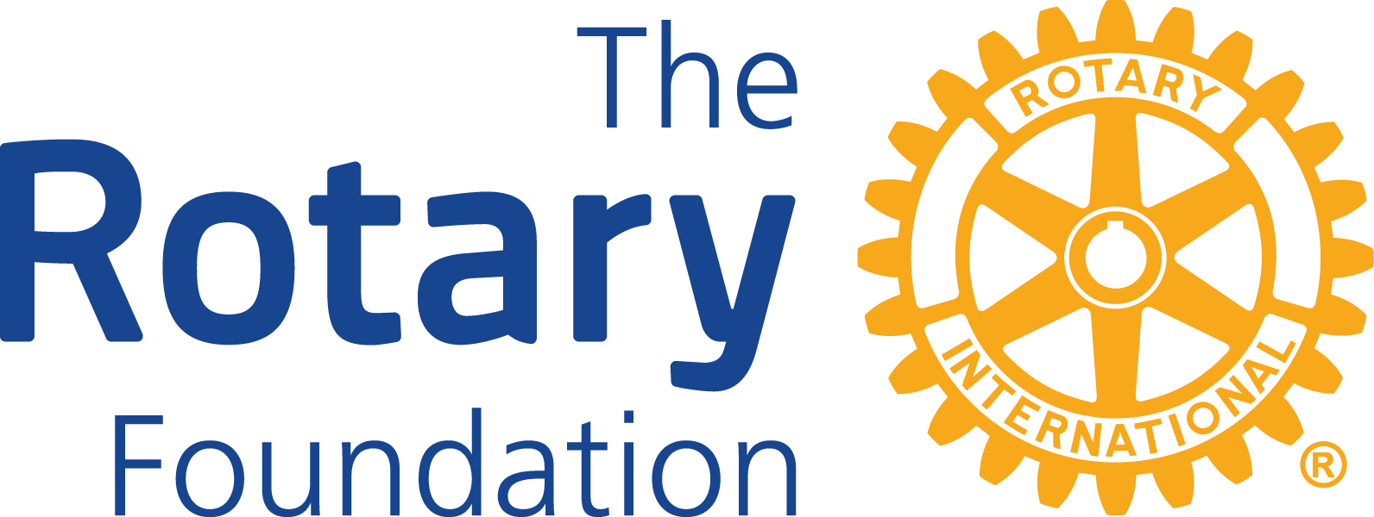

District 6420
District Grant Partner Memorandum of Understanding

Organization's full legal name:____________________________________________________

Address:______________________________________________________________________

Website:______________________________________________________________________

Project title:___________________________________________________________________

Agreement: Place an “X” on the line in front of each statement that is true.

_____ The organization listed above agrees to partner with the Rotary Clubs of

___________________________________ for administration of this project, if District Grant funds are received, by doing the following:
- Assess the furniture needs for clients.
- Submit the order for Rotarians to review.
- Assist as needed in unpacking and assembling furniture.
- Provide proper documentation for publicity.

_____ The organization listed above agrees, if it is not possible or practical for the Rotary Club to pay grant money directly to the provider of goods or services, to:
(a) Pass through the grant money to the ultimate provider of goods or services in full without deduction; and
(b) Provide in a timely fashion a paid receipt from the ultimate provider of goods or services, in an amount at least equal to the grant payment.

2023-2024 Rotary Club President-Elect Organization Representative

Name:_______________________________ Name:_____________________________

Signature:___________________________ Title:______________________________

Email:_______________________________ Signature:_________________________

Email:_____________________________

This form must be emailed with the District Grant Application.

