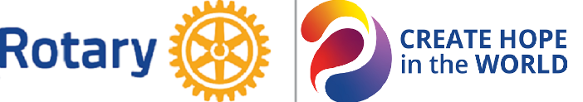
District 6420
Application for
Club Achievement in Literacy Recognition
During the 2023-2024 Rotary Year

Due Date: Thursday, March 21, 2024
Format: Only emailed nominations will be accepted. Please email your nomination to District 6420 Literacy Committee Chair, Andy Axup at AxupAndrewW@sau.edu.
Number of Awards: All clubs which meet recognition criteria.
For More Information: Call District 6420 Literacy Committee Chair, Andy Axup at 563-424-6194.

Name of Club: _________________________________________________________________________

Name of Person Submitting This Nomination: _______________________________________________

Position in Club: _______________________________________________________________________
Club Literacy Contact or Chair: ___________________________________________________________

Email Address: ______________________________________________________________________

Phone Number: ______________________________________________________________________

Criteria for Club Achievement in Literacy Recognition:
- A Rotary Club demonstrating achievement in all four areas listed below during the 2023-2024 Rotary year.

1. Awareness Activities. (Please respond to either A or B.)
A. Club program or speaker on literacy. Please provide the date, the name of the speaker, and their topic.

B. Club activities in the community, such as newspaper articles or social media posts, PSAs on radio or television, distribution of brochures on literacy, floats in a parade, etc. Please provide the date, a short description of the activity, and the number of Rotarians involved.

2. Monetary or Material Donations to a Community Literacy Program. (Please provide the name of the organization, the project that was supported, and a description of the donation.)

3. Hands-On Volunteer Literacy Activities by Club Members. This might include tutoring, service on a local literacy board or task force, helping with a book fair, building shelves for a library, etc. Allowance will be made for activities suspended or modified due to COVID restrictions. (Please provide the date the activity occurred, what direct assistance was provided, and the number of Rotarian hours accrued.)

4. Celebration of Literacy Awareness Month Activities in July (Rotary International), November (state of Illinois), or March (Dr. Seuss Birthday). These activities must not overlap with activities listed in #1, #2, or #3 above. (Please provide the date of the celebration, what activity was done, and the number of Rotarians involved.)

