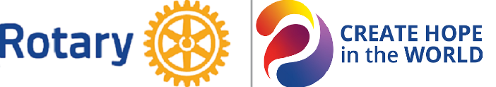
District 6420
2023-2024 Nomination for
The Majiyagbe Award for Innovative Literacy Project

Due Date: Thursday, March 21, 2024
Format: Only emailed nominations will be accepted. Please email your nomination to District 6420 Literacy Committee Chair, Andy Axup at AxupAndrewW@sau.edu.
Number of Awards: 1
For More Information: Call District 6420 Literacy Committee Chair, Andy Axup at 563-424-6194.

Name of Club: _________________________________________________________________________

Name of Person Submitting This Nomination: _______________________________________________

Position in Club: _______________________________________________________________________

Criteria for the Majiyagbe Award for Innovative Literacy Project:
- A club-initiated, innovative project occurring during the 2023-2024 Rotary year that made an impact on awareness of or support for a literacy provider such as a school or library.
or
- A unique volunteer literacy project developed by a club for its members that occurred during the 2023-2024 Rotary year.

Description of Club Project: Describe your club’s innovative literacy project. Attach newspaper articles, social media posts, and other supportive documents.

