`
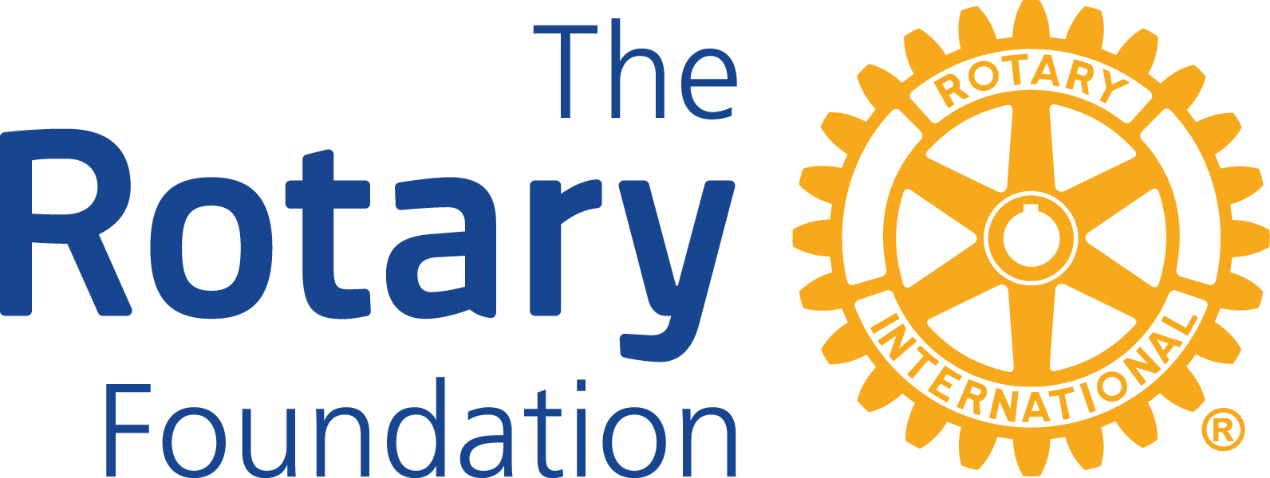

District 6420
District Grant Partner
Memorandum of Understanding

Organization's full legal name:____________________________________________________

Address:______________________________________________________________________

Website:______________________________________________________________________

Project title:___________________________________________________________________

Agreement: Place an “X” on the line in front of the second statement if that is true.
X
_____ The organization listed above agrees to partner with the Rotary Club of

___________________________________ for administration of this project, if District Grant funds are received.

_____ The organization listed above agrees, if it is not possible or practical for the Rotary Club to pay grant money directly to the provider of goods or services, to:
(a) Pass through the grant money to the ultimate provider of goods or services in full without deduction; and
(b) Provide in a timely fashion a paid receipt from the ultimate provider of goods or services, in an amount at least equal to the grant payment.

2025-2026 Rotary Club President-Elect Organization Representative

Name:_______________________________ Name:_____________________________

Signature:____________________________ Title:______________________________

Email:_______________________________ Signature:_________________________

Email:_____________________________

Include this signed document with your 2026-2027 District Grant Application.

