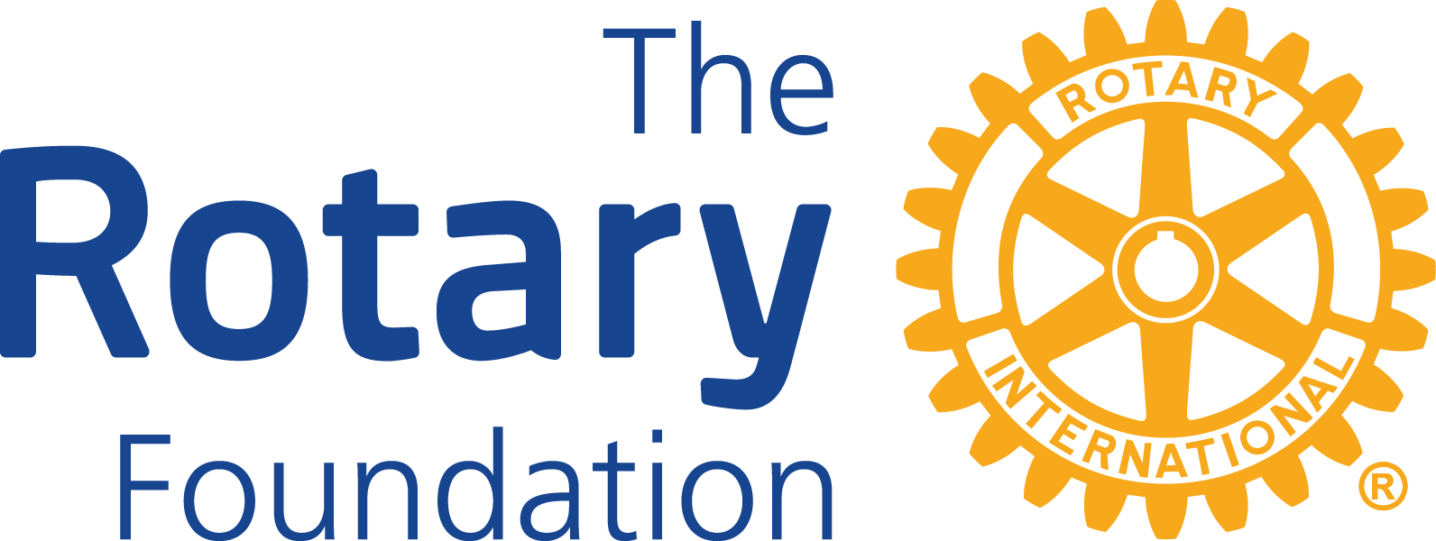

District 6420
District Grant Application for 2024-2025

Application Deadline: May 15, 2024
(All applications must be typed and submitted via email to RotaryDistrictGrants@gmail.com)

COVER PAGE

Rotary Club of: ________________________________________________________________

Project title: __________________________________________________________________

Amount of funds requested from District 6420 (up to $1200): _________________

Amount of funds committed by your Rotary Club for this project: _____________________

Total project budget: __________________

2024-2025 Club President: _______________________________________________________
(name) (e-mail)

2024-2025 Club Grants Chair: ____________________________________________________
(name) (e-mail)

2024-2025 Club Chair of this project: _______________________________________________
(name) (e-mail)

2024-2025 Club Treasurer: _______________________________________________________
(name ) (e-mail )

Person to whom check should be sent:

(name) (email) (phone)

(complete mailing address)

If multiple Clubs are partnering on this project, please submit a Cover Page for each Club.

Rotary Club of: ________________________________________________________________

APPLICATION NARRATIVE
(Please answer the following questions in narrative form.)

1. Briefly describe the proposed project. What will be done, when, where, and who will benefit from the project?

2. How many Club members will participate in the project and in what role?

3. Is there a partnering organization also involved? Provide their name; project contact’s name, title, and email address; and what their role will be.

4. How will the project benefit the community and for how long? Approximately how many people will benefit from the project?

Rotary Club of: ________________________________________________________________

5. How does this project reflect the mission of The Rotary Foundation? Be specific.

6. Include an itemized budget (below or attached) with documentation of cost estimates from all vendors. The cost estimates should add up to the total project budget.

Rotary Club of: ________________________________________________________________

APPLICATION REQUIREMENT CHECKLIST
(Please place an “X” on the line in front of each statement that is true.)

Eligibility Requirements

_____1. The Club President for the 2024-2025 Rotary year completed a District Grant Management Training Seminar during 2024.

_____2. The Club Grant Chair or Foundation Chair for the 2024-2025 Rotary year completed a District Grant Management Training Seminar during 2022, 2023, or 2024.

_____3. This Club’s Goals for the 2024-2025 Rotary year have been entered into Rotary Club Central.

_____4. This Club and/or its members have contributed to The Rotary Foundation Annual Fund during 2021-2022, 2022-2023, or 2023-2024 Rotary year.

_____5. This Club has identified a Foundation Chair for the 2024-2025 Rotary year.

_____6. The District Grant Final Report for the 2023-2024 Rotary year was submitted to Kelly Giovanine at RotaryDistrictGrants@gmail.com by May 15, 2024.
Project Requirements

_____7. This is the only District Grant Application that this Club is submitting for the 2024-2025 Rotary year.

_____8. This Club is contributing its own matching funds to this project.

_____9. This project is consistent with the Terms and Conditions for Rotary Foundation District Grants and Global Grants (published March 2023).

_____10. This project is consistent with the Areas of Focus Policy Statements (published September 2023).

_____11. This project is consistent with the mission of the Rotary Foundation.

_____12. This project addresses a humanitarian, public safety, or educational need in the community.

_____13. This is a new project that has not been started and has not been done as part of a District Grant for at least 3 years.

_____14. This is not a beautification project.

_____15. This is not a fund-raising project.

_____16. This project involves the active participation of Rotarians.

_____17. This Club will promote this project to local media and on social media, as appropriate.

_____18. This project will be completed no later than May 15, 2025.

_____19. Cost estimates from all vendors are included with this Grant Application. The cost estimates add up to the total budget for the project.

_____20. The grant money will be paid directly to the provider of goods and services or to a partnering organization.

_____21. If a partnering organization is involved, a Memorandum of Understanding has been completed and is included with this Grant Application.

_____22. The Rotary International Club Qualification Memorandum of Understanding (3 pages) and the Rotary District 6420 Memorandum of Understanding Addendum to The Rotary International Club Qualification Memorandum of Understanding (1 page) have been completed and are included with this Grant Application.

_____23. This Club agrees to submit a Final Report for this project using the District 6420 District Grant Final Report form and complying with its requirements by May 15, 2025.

If multiple Clubs are partnering on this project, please submit an Application Requirement Checklist for each Club.

Rotary Club of: ________________________________________________________________

SIGNATURES

2023-2024 Rotary Club President

Name:_________________________________

Signature:______________________________

Email:__________________________________

2024-2025 Rotary Club President

Name:_________________________________

Signature:______________________________

Email:__________________________________

2024-2025 Rotary Club Grants Chair or Foundation Chair

Name:_________________________________

Signature:______________________________

Email:__________________________________

If multiple Clubs are partnering on this project, please submit a signature page for each Club.

*******************************************************************************************************************

Email completed applications (including cost estimates for all vendors and all three MOU’s) by May 15, 2024 to:

Kelly Giovanine
District Grant Subcommittee Chair
RotaryDistrictGrants@gmail.com

