**`**

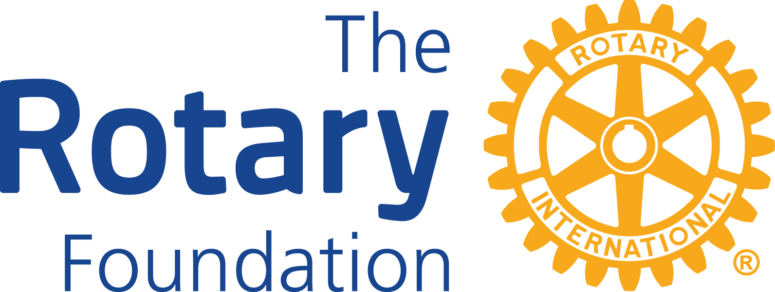

**District 6420**

**District Grant Partner**

**Memorandum of Understanding**

**Organization's full legal name:____________________________________________________**

**Address:______________________________________________________________________**

**Website:______________________________________________________________________**

**Project title:___________________________________________________________________**

**Agreement:** Place an “X” on the line in front of the second statement if that is true.

X

_____ The organization listed above agrees to partner with the Rotary Club of

**___________________________________** for administration of this project, if District Grant funds are received.

_____ The organization listed above agrees, if it is not possible or practical for the Rotary Club to pay grant money directly to the provider of goods or services, to:

(a) Pass through the grant money to the ultimate provider of goods or services in full without deduction; and

(b) Provide in a timely fashion a paid receipt from the ultimate provider of goods or services, in an amount at least equal to the grant payment.

**2024-2025 Rotary Club President-Elect Organization Representative**

**Name:_______________________________ Name:_____________________________**

**Signature:____________________________ Title:______________________________**

**Email:_______________________________ Signature:_________________________**

**Email:_____________________________**

**Include this signed document with your 2025-2026 District Grant Application.**