Go To My Rotary.......and log in.

Move cursor to header of Learning and Reference.

Learn by Topic.

Click on.Membership.

Scroll down to Connect with Prospective Members.

and choose Customizable Club Brochure.

the Create your own Screen page appears.

Click on Rotary Club Brochure.

Click on Create at bottom right of screen.

OK - you're there. Now you can fill in panel info as you wish by entering
content on right hand side of the page. All Headers can be used for Club
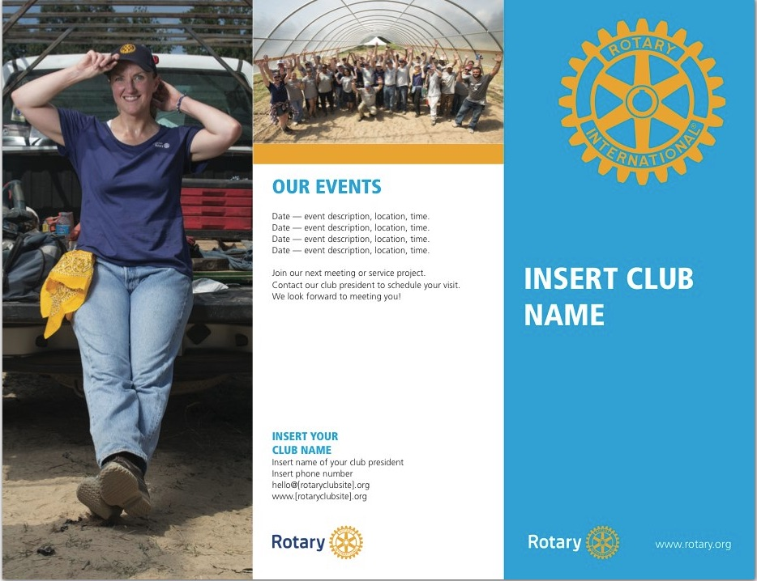
specific use.
