Global Grant - Erasmo Meoz Hospital
CUCUTA – COLOMBIA
$63,200

Partner Clubs San Jose de Cucuta in Colombia and Baytown in Houston
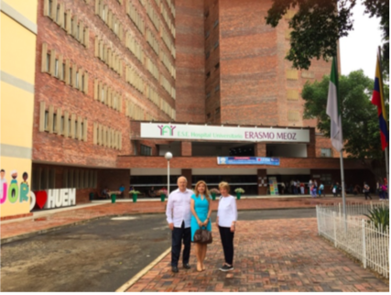

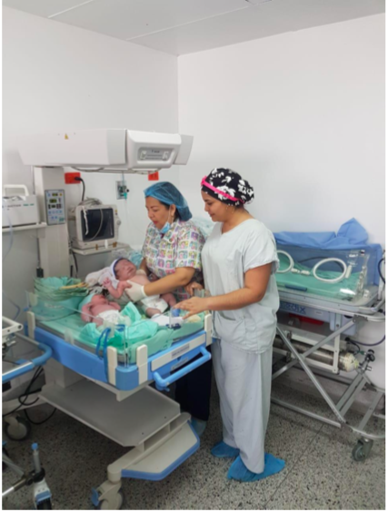

The Erasmo Meoz Hospital is a hospital that serves the North Santander, the Arauca, the Cesar and the Boyacá departments in Cucuta Colombia, as well as the population of Venezuela “living” in Cucuta due to its location on the border. At the moment the greatest needs are in the gynecology-obstetric and newborn services. Due to the absence of pediatric medical equipment, there are many complications and the number of Venezuelans requiring hospitalization and surgical and emergency care is very high.
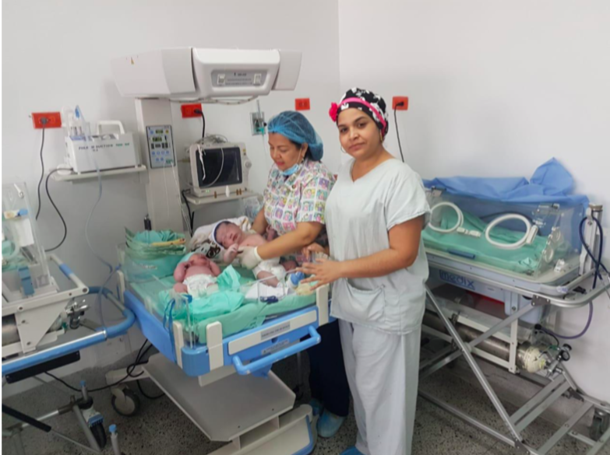

The Medical Equipment needed is:
- Vehicle viewer $11,531
- Double wall YP90A incubator $8,289
- Radiant heat lamp HKN93B includes phototherapy light $7,775
- Vital signs monitor iM50 $2,136
- Scale with Neonatal Tallimeter $1,662
- Vacuum cleaner $301
- Reanimator for infants.$11,494
- Synovent fan E3 adult/pediatric vendor $20,042
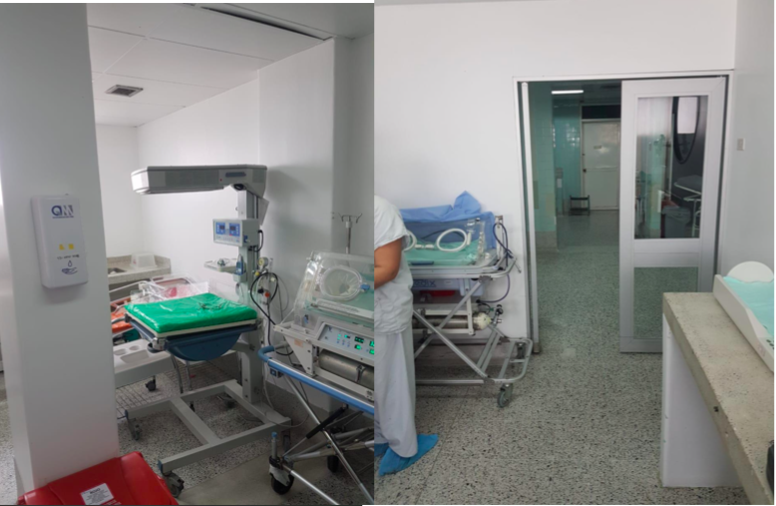
Total $63,230

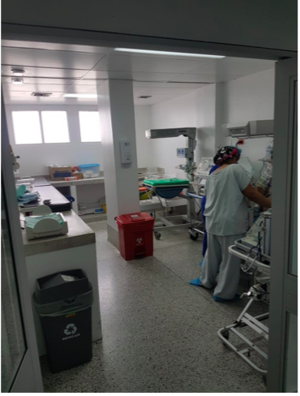

Total project cost approximately $63,237
Contacts
Gladys Maldonado Rodríguez in Cucuta- gladysmal@hotmail.com
Bill Davis in Houston- billd@kingwoodcable.com or 281 543-4521

