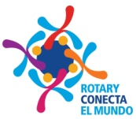
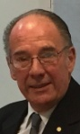
DISTRITO 4975
LA FUNDACION ROTARIA
Presidente del COMITÉ DISTRITAL
Período 2019 - 2020

Montevideo, February 2020

Chairman of District Committee of
The Rotary Foundation - District 5180
Mr. Glen Fong

Dear Colleague,

Honoring the Motto of the President of Rotary International 2019-2020 Mark Daniel Maloney “Rotary connects the World”, let me introduce myself: I am: Juan José Padilla Scanagatta, Chairman of District Committee of The Rotary Foundation- District 4975 - Uruguay

The reason of this letter is to ask for financial support to Rotary World, in order to do a great work in Uruguay. We need an Echograph
It consists in the purchase of an ultrasound machine which is urgently needed in the Maternity Department of our country’s largest Assistance Center named “Pereira Rossel”. It assists almost 50% of mothers of the country and their babies These women have little or scarce resources.
In turn, gynecologists, as well as students graduated from Public and Private Schools of Medicine, carry out their internships in this place.
This ultrasound will give us the possibility of having a state-of-the-art Prenatal diagnostic unit with great fidelity, since it has a 4D vision, which gives us almost 100% security in the diagnoses. We can treat multiple pregnancies, see if the fetus comes with any deficiency; either of malformation, as a possible tumor disease. This would broaden the spectrum of the best care for the patient (mother) and her child. We can see in real time, within the womb of his mother, the state of health of that little being with total clarity, which at this time the equipments we have do not allow us to do it. Besides, this will also let have best and more experienced doctors which will result in a better and safer attention to the Mother and her son or daughter.

VOLUSION E 10 Echograph – Brand: General Electric.
Its value is US $ 109,580. - Which it is a very important figure to us.
We have US $ 16,000. - of FDD. The Global Fund of LFR would support us with an identical amount. So we will get US $ 32,000.-
We need support from some Districts to get the balance (US $ 77,580.-) although we know we only need to get US$ 38,790 as Global Found will provide us with another equal amount.
Among the Districts that could give us any support with any amount we hope to do a great job. I always say that we have to push to do things (sometimes we win, sometimes not) but the effort always have to be done.

At name of District 4975 and myself I am looking forward to hearing from you with a positive answer as soon as possible.
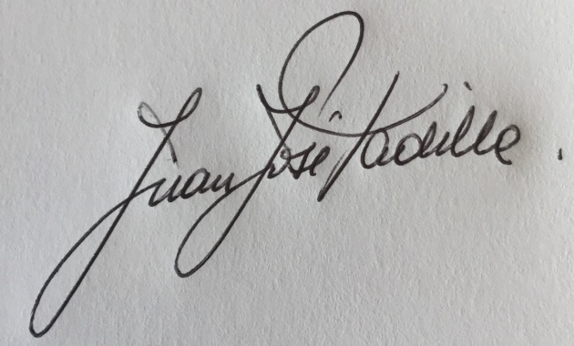

Juan José Padilla Scanagatta
Chairman of the District Committee -
The Rotary Foundation - District 4975
Montevideo, Uruguay

PS. At your request, we are gladly to send the Project at once.
Please note that Uruguay is a small country with great health deficiencies.
All the support you can give to this project will be greatly appreciated by our country.

