Name:

Rotary Club:

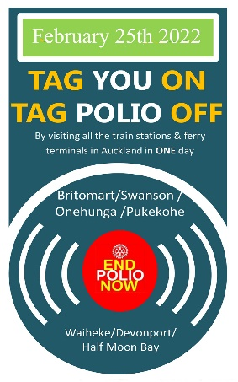
Help me contribute to the Global Polio Eradication Campaign and sponsor me as I ride the Auckland train network on Friday 25th 2022 as part of Rotary’s fundraising event to #tagpoliooff.
There are over 40 train stations & several ferry terminals and my aim is to visit as many as possible between 8am and 6pm.
You are welcome to be part of the fun and join in.
Contact me for more information!

SPONSOR NAME | SPONSOR  CONTACT INFO | PLEDGE AMOUNT PER STATION | FINAL AMOUNT

