D9910 Centurion Programme
The D9910 Centurion programme is the simple way to make a personal contribution to
The Rotary Foundation

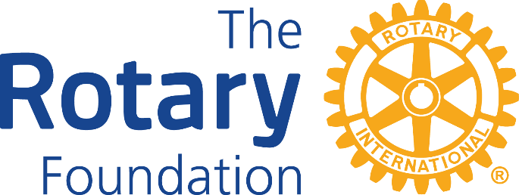

An annual donation of $100 to the Centurion programme helps the
Rotary Foundation to provide grants which empower Rotarians to confront challenges such as poverty, illiteracy, and malnutrition and deliver sustainable solutions that leave a lasting impact.

Your gift at work; Doing Good in the World
Please make the Rotary Foundation your charity of choice.

Rotary: Making a Difference. “Whether we’re building a new playground or a new school, improving medical care or sanitation, training conflict mediators or midwives, we know that the work we do will change people’s lives — in ways large and small — for the better.”

YOU can help…… by supporting your District’s Centurion programme
- The Centurion programme welcomes all supporters.
- It is an excellent way for Rotarians, Foundation Alumni, Friends of Rotary and all non-Rotarians to support the Rotary Foundation’s efforts for the improvement of the lives of millions of people around the world.
By joining the Centurion Programme you will be playing a small but vital part in this effort.
- A contribution of $100NZD or more annually will enrol you as a member of the Centurion Programme – and remember, your partner, family, friends, colleagues and companies are all welcome to join.
- Every new member receives a certificate and a distinctive lapel pin.
- Your donation to the Centurion Programme will be receipted and is tax deductible.

Please pledge your donation today and become a part of Rotary’s life-changing work!
-------------------------------------------------------------------------------------------------------------------------------
Yes! I would like to become a donating member of Rotary District 9910’s Centurion programme.

Title: ............. .........First Name: ..................................................Family Name: ………...................................................
Address:
...........................................................................................................................................................................................

…………………………………………………………………………………………………………………………………………………………………………………….
Tel: ...................................................................................................................................................................................
Email: ...............................................................................................................................................................................
Rotary Club of: .................................................................................................................................................................

For electronic transfer of funds: Please use your name and your club as references and pay to:

ANZ Bank Account: 01-0125-0146572-02
Account Name: Rotary District 9910 Foundation Committee (Centurion Account)
Branch: Onehunga

OR set up an Automatic Payment to the above account and inform Grant Smith of the date.
Automatic payments can be set up online through your account OR by talking to your bank.

Send your completed form to the contact below and advise them of the date of payment and/or Automatic Payment:
David Oliphant
Centurion Co-ordinator
Email: doliphant.rotary@gmail.com

Thank you most sincerely for your support. It really does make a difference.

