District 7070 DEI Committee
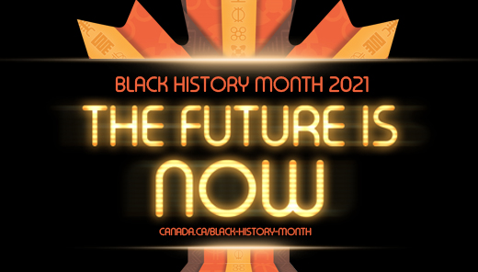
https://www.canada.ca/en/canadian-heritage/campaigns/black-history-month.html
https://www.canada.ca/en/canadian-heritage/campaigns/black-history-month.html
https://antiracism.utoronto.ca/black-history-month-2021/
https://www.etfo.ca/BuildingAJustSociety/EquityResources/pages/blackhistory.aspx
