District 7070 Speakers Bureau
Date Speaker Added : August 17, 2023
Speaker: Bobby McBride
Speaker's Category: Mental Health
Speaker's Topic: Addiction
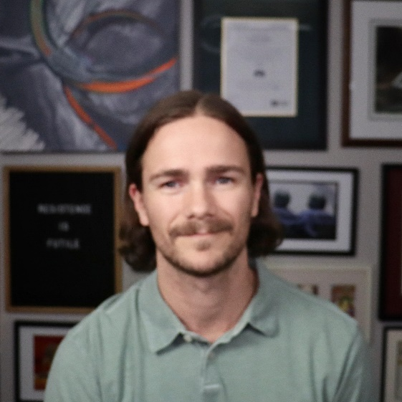
Bobby is a member of the Rotary Club of Whitby Sunrise. He is a former professional athlete who developed an unhealthy relationship with alcohol. He stopped drinking alcohol over 4 years ago and the next step in his journey is to share his story with others. He has delivered his presentation to the Whitby Sunrise Club and the Ajax Club. It has been well received and I think other clubs would benefit from hearing his story. In his presentation he explains what alcohol is, his experience with it, and how he was able to change his behavior.

Recommender's Name: Mark Chipman
Recommender's Club: Whitby Sunrise
Recommender's email address:chipburt@hotmail.com
Speaker's Category: Mental Health
Speaker's Topic: Addiction
Speaker Name: Bobby McBride
Speaker Tel: 416-996-7190
Speaker Email: bobby@planningandinvesting.com
Speaker Bio: Bobby has been a Rotarian since February 2019. He is active in the community outside of Rotary sitting on the board of directors for Durham Community Foundation, Downtown Whitby BIA, Station Gallery, and Ontario Association of Credit Counselling Services. In addition, he is heavily involved with the Durham Region Toastmasters Club and is a member of the Durham Mountain Biking Association. He played hockey in the OHL and lacrosse in the National Lacrosse League. He now enjoys creating artwork for friends, family, and charity. His works have been displayed in the Station Gallery. Professionally, he operates an independent wealth management practice.

