Rotary District 7070 Youth Exchange Program
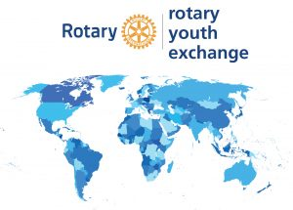

Eligible Students Apply Here!

Do you want to travel? Applications for eligible outbound students who will begin their travel in August of next year, are accepted until late October. See below for eligibility guidelines.

Here is your link to apply: https://yehub.net/cgi-bin/C07_get.cgi?pgid=apob0
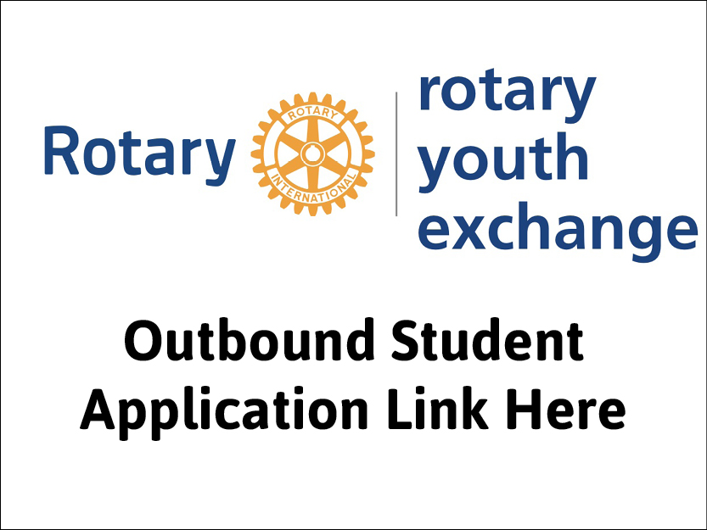
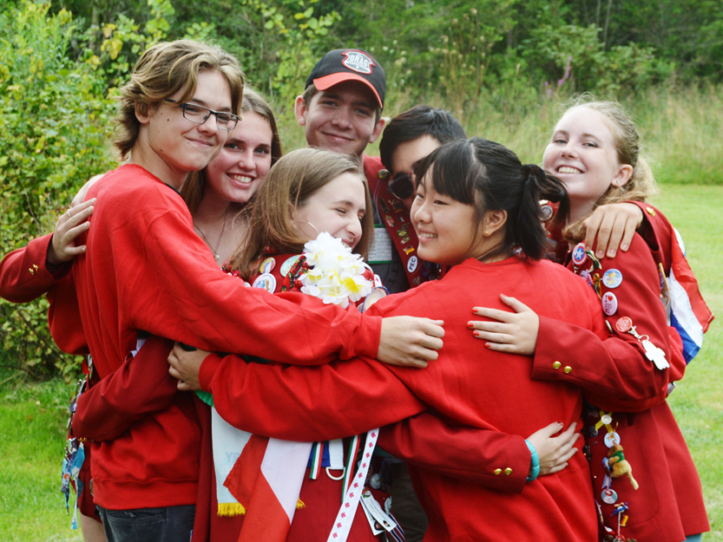

Who is Eligible?

Full time public secondary school students in grades 10 or 11 who are:
- Canadian citizens
- At least 16 but not yet 18 at the time of departure in August of their exchange year, (next year)
- Of good character, reputation and must be in good health with no significant pre-existing medical conditions
- Would receive a recommendation from their school
- Endorsed by a YE participating local Rotary Club.

