Rotary District 7070 Youth Exchange Program
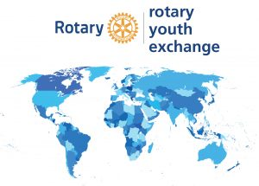

DISTRICT 7070 ROTEX

What is Rotex

Rotex is a society of past Rotary Youth Exchange (RYE) alumni that engages with current Inbounds and Outbounds to better their exchange experience overall.
Rotex acts as a middleman between Rotary Clubs and exchange students through supporting Rotarians throughout the RYE program via mentoring students on proper etiquette while on exchange, organizing trips and events for Outbounds, Inbounds, and Rebounds, and ultimately being the voice for RYE exchange students in many cities, districts, and countries in the Rotary world.
We see Rotexers as potential future Rotarians and therefore aim to develop the next generation of Rotarians who have first-hand Rotary experience.

Terminology
- Rotary Youth Exchange (RYE):
Rotary International’s worldwide youth exchange program. The program is organized at the district or multidistrict level.
- Outbound:
An RYE student before and during exchange, from the perspective of their sponsoring district(s).
- Inbound:
An RYE student before and during exchange, from the perspective of their host district(s).
- Rebound:
An RYE student after they have completed their exchange year and returned to their home country.
- RYE Alumni:
All former Rotary Youth Exchange program participants.
- Rotex:
RYE alumni who actively support the RYE program and its participants.
- Rotex Club:
An association of Rotex, usually covering the same area as its respective RYE program. This is most often organized at the district or multidistrict level.

