Rotary District 7070 Youth Exchange Program
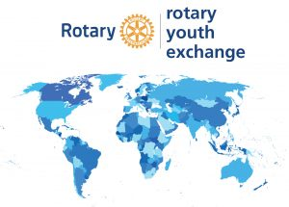

HOST FAMILIES - Become a Host Family
A host family is a vital part of the cultural exchange, immersing the student in a variety of activities while in the host country. The host family plays a large role in offering the student a view of another country and gains the opportunity to learn about a new culture from a young leader.

Hosting is a tremendous experience in which you can share in a young person’s hopes and dreams and develop a lifelong connection with a student and family from another country. It can be challenging to help a young person transition to a new culture and ease into the surroundings but the rewards are immeasurable.
Host families in the Youth Exchange program come in all shapes and sizes.
They can be Rotarians or non-Rotarians, and they may include young children,
older children, or no children at all.

APPLY HERE TO BECOME A HOST FAMILY

What is expected of a host family?

Hosting a student can be an extremely rewarding experience for everyone in the family, yet it is a role that requires a lot of responsibility. Host families are screened, selected and supported by their respective districts.

As a host family, you will be in close contact with members of your local Rotary Club and district. If you are interested in becoming a host family, contact your local club’s Youth Exchange representative or simply apply and someone will contact you.

For more information about hosting, watch the video or download the guides available below.

Click here and watch what others are saying about hosting.

Guide for Host Families – District 7070

A Guide for Host Families RI

Host Family Primer RI

