Rotary District 7070 Youth Exchange Program
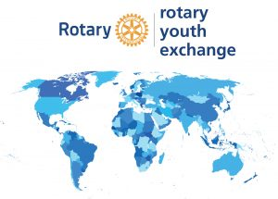

LONG TERM EXCHANGE PROGRAM

Exchange Program Information
Long-Term exchange is open to students ages 16 to18 and usually last from 10 to11 months. D7070 stipulates that a student must be 16 years of age when arriving for exchange but not yet 18 years old. The student will live with more than one family in your host country and is required to attend high school regularly as a full time student.

To ensure student’s safety, the host Rotary club conscientiously screens and selects all host families.

To qualify, applicants should be above-average students who have demonstrated leadership in their community. All applicants must be sponsored by a local Rotary Club and complete a written application and in-person interview.

For more information, check out the resources provided here. You can also contact your local Rotary Club.

Rotary Exchange Costs

Youth Exchange Handbook RI

Guidelines for Outbound Students

Long-Term Youth Exchange Leaflet RI

Long-Term Youth Exchange Brochure RI

A Primer for Exchange Students RI

A Guide for Exchange Students RI

