Rotary District 7070 Youth Exchange Program
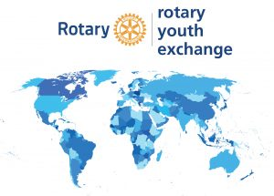

District 7070 Participating Youth Exchange Clubs

Sponsoring Clubs & Contact Information

Rotary Club of Brighton
http://www.brightonrotary.ca/
Club Contact: Ricardo Melendro
rmelendro@gmail.com

Rotary Club of Campbellford
http://www.rotaryclubofcampbellford.ca/
Club Contact:
info@campbellfordrotary.ca

Rotary Club of Cobourg
http://www.cobourgrotary.ca/
Club Contact: Brian Bruce
brucey67@hotmail.com

Rotary Club of Northumberland Sunrise
https://sunriserotary.ca
Club Contact:

Rotary Club of Port Perry
http://www.rotaryclubofportperry.com/
Club Contact: Aubrey Oppers
aubrey@oppers.ca

Rotary Club of Trenton
https://www.trentonrotary.ca/
Club Contact: Rob Hardy
rob_hardy@can.salvationarmy.org

Rotary Club of Stirling
http://www.stirlingrotary.ca/
Club Contact: Trevor Hagerman
trevor@thlogistics.ca

