Rotary District 7070 Youth Exchange Program
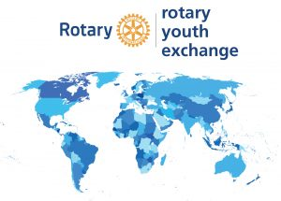

USEFUL LINKS

Rotary District 7070 Ontario Canada
https://www.rotary7070.org/

Rotary Foundation of Canada
https://trfcanada.org/

Rotary International
https://www.rotary.org/en

