## **Rotary District 7070 Youth Exchange Program**

[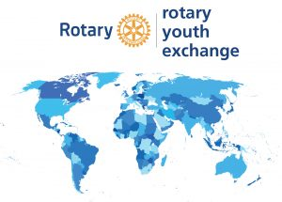](https://rotary7070.org/Committee/youth-exchange-3)

# **USEFUL LINKS**

**Rotary District 7070 Facebook Page** - [https://www.facebook.com/rotary7070](https://www.facebook.com/rotary7070%20)

**Rotary District 7070 Ontario Canada -** <https://www.rotary7070.org/>

**Rotary District 7070 Club Directory -** <https://rotary7070.org/clubdirectory>

**Rotary District 7070 Map of Clubs** - <https://rotary7070.org/clubsmap>

**Rotary Foundation of Canada -** <https://trfcanada.org/>

**Rotary International -** <https://www.rotary.org/en>

**YEO and Students - YEAH access** - [https://yehub.net/C07-obapp](https://yehub.net/C07-obapp%20)

**YE Committee - YEAH access** - [https://yehub.net/C07.php](https://yehub.net/C07.php%20)

### 