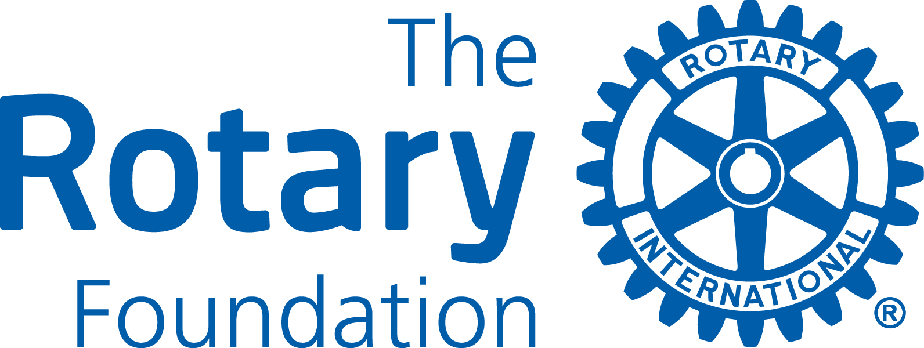

APPLICATION FORM
Please, read the instructions at the end of this document. Rotary and Rotarian also refer to Rotaract and Rotaractor throughout this document. Please, type the information you enter.

- GENERAL INFORMATION

Applying Rotary Club
Project title
Area of Focus

Has the applying Club any unfinished District Grant projects? Yes __

If Yes, please specify _________________________________________________________

Has final reports for all previous District Grant projects been submitted and accepted Yes __

Is the Club qualified for the 2025-26 Rotary year at the time of submitting this form? Yes __

Has the Club entered its goals in Rotary Club Central for 2025-26? Yes __

- PROJECT DESCRIPTION

Project Goal
Project Overview

Location
Project start/finish
Partners (if any)

Other information

- HOW WILL THIS PROJECT BENEFIT THE COMMUNITY?

Please, describe the benefits for the receiving community from this project.

- ROTARY/ROTARIAN/BENEFITTING COMMUNITY PARTICIPATION

Please, describe any non-financial participation by Rotarians, Rotaractors and members of the benefitting community. This may include needs assessment and partnerships developed, hands-on participation, and communication strategies to enhance the profile of Rotary, Rotaract and the Rotary Foundation

,
Estimated volunteer hours in the project by Rotary and Rotaract members ___________

- PROJECT CONTACTS

The Primary (applying) Club must appoint a committee of at least three members from its Club to oversee the project. The committee members must be committed for the duration of the grant project. Please, provide the mailing and email address for all committee members. The primary contact will receive all official communication from District 7070 and should share that information with the other committee members.

Contacts
Name (Prime)
Address
Phone/Email
Name
Address
Phone/Email
Name
Address
Phone/Email

- PROJECT BUDGET

 | Item/Supplier | Amount (CAD)
1
2
3
4
5
6
7
9
9
10
Total Project Budget

- SOURCES OF FUNDS

Total Project Funding
Source | Name of Clubs and other contributing sources | Amount (CAD)
Primary Club Cash
Other D7070 Clubs
Other Sources
District Grant Request
Total Project Funding

Please note, that Total Project Budget must equal Total Project Funding

Project with more than one Club, that are fully funded by May 31.2025, will be prioritized when applications are evaluated to be included in the District’s Spending Plan (the District’s application to the Rotary Foundation for DDF to be used as District Grants). Please, attach the confirmation letters/emails from supporting Club to the application.

- OWNERSHIP OF EQUIPMENT OR SUPPLIES

- Who will own equipment, materials, or supplies, once the project has been completed? (Rotary and Rotaract Clubs cannot own materials and supplies)

- Who will be responsible for future maintenance, operations and/or future costs for the equipment?

- ROTARY/ROTARACT BRANDING AND PUBLIC IMAGE

How will the general public know that this is a Rotary/Rotaract and Rotary Foundation project? Please, provide details about outreach to media (radio, TV, print & online), social media and how the Rotary Masterbrand Signature and the Rotary Foundation logo will be used on project materials and communications.

- CO-OPERATING ORGANIZATIONS

If the project involves one or more co-operating organizations, please provide the name of each organization and attach a letter of participation that specifically states its responsibilities and how Rotarians will interact with each organization of the project. By signing this application, the Primary Club endorses the organization as reputable, responsible and acting within the law.

Name of Co-operating Organization/s

- AUTHORIZATION

- Progress and Final Reporting Requirements
The Primary Club is required to complete and submit progress and final reports to the District Grant Sub-Committee. Please, indicate below the individual (including contact information), who will be responsible for submitting the reports.

- Club President’s Authorization
As President of the Rotary Club of ___________________________________________________
I hereby affirm that the Club has voted to undertake this project as an activity of the Club

 | 11 a. Primary Club Contact | 11 b. Club President
Signature
Name
Date
Phone
Email

Don’t forget to save your completed form.
Submit your application by email no later than May 31, 2025 to pdglars.henriksson@gmail.com

Please, also feel free to contact Lars for questions and further information.

End of Application Form

Instructions

District Grants are used to support short-term projects of individual Rotary/Rotaract clubs in District 7070. Clubs apply to the District 7070 Foundation Grant Sub-Committee which decides the merit of each application and the degree to which they will be funded. An application is not a guarantee for a grant!

The Rotary Foundation Terms & Conditions for District Grants
District Grant projects must comply with the Terms and Conditions of The Rotary Foundation District Grants and relate to the Mission of the Rotary Foundation (see below). These terms and conditions are available on District’s website at www.rotary7070.org and at www.rotary.org.

The mission of The Rotary Foundation of Rotary International is to enable Rotarians to advance
world understanding, goodwill, and peace through the improvement of health,
the support of education, and the alleviation of poverty.

For complete rules and regulations for District Grants, please consult Terms and Conditions for Rotary Foundation District Grants (July 2024) which can be downloaded from Grant Resources at the Grant Center site on the Rotary Foundation https://grants.rotary.org/s_main.jsp?lang=1

District 7070 Grant Guidelines
- Projects must fall within one of the Rotary Foundation’s seven areas of focus:
  - Peace and conflict prevention/resolution
  - Disease prevention and treatment
  - Water, sanitation and hygiene
  - Maternal and child health
  - Basic education and literacy
  - Economic and community development
  - Environment and Sustainability
- Projects may take place anywhere in the world; however, a minimum of 25% of the District’s total District Grants funds will be allocated to projects in District 7070.
- Applications for District Grants in the 2025-26 Rotary year should be submitted no later than the deadline May 31, 2025, to be considered and included in the District’s Spending Plan for approval by the Rotary Foundation for District Designated Funds (DDF).
- Applications received after May 31, 2025, may be considered if funds remain.
- The Primary (applying) Rotary/Rotaract Club in a project must be qualified for the 2025-26 Rotary year by May 31, 2025, according to The Rotary Foundation rules. Qualification is either completed online at www.rotary7070.org (under the Foundation menu), or by attending special workshop/seminars organized by the District.
- Applications should be for an original effort; recurring projects will not be considered for funding.
- The budget for a project must be a minimum of CAD1,000.
- To encourage Clubs in District 7070 to co-operate and create larger projects, the District will use the formula below to match every D7070 Club’s cash contribution of CAD in District Grant projects, subject to funds being available.
D7070 Clubs in the Project | 1-2 | 3-4 | 5 and more
Club Cash vs DDF (max) | 1 : 0.50 | 1 : 0.75 | 1 : 1
Max DDF/Club & Project (CAD) | 1,000 | 1,500 | 2,000
Max. DDF/Project (CAD) | 2,000 | 6,000 | 9,000

- The maximum amount that may be allocated to District Grant projects for the 2025-26 Rotary year is estimated to be the equivalent in Canadian dollars of USD54,000 (50% of new DDF), based on funds raised in the District for the Annual Fund of the Rotary Foundation three years ago.
- Due to lower DDF than previous years, the District will likely allocate less than the maximum allowed amount of DDF for District Grants .
- The actual amount of new DDF requested for District Grants from the Rotary Foundation by the District will be based on applications received by May 31, 2025, and other usage of DDF, e.g. contributions to PolioPlus and matching of Club Cash in Global Grant projects.
- District Grants can’t be combined with a Global Grant.
- Any unused District Grant funds allocated to a specific project must be returned to the District. This may occur for any number of reasons (e.g. the project does not happen, the project expenses are less than budgeted, fewer clubs participate etc.).
- An application is NOT a guarantee for receiving a District Grant.
- Applying Club for a project receiving a District Grant is responsible for meeting the reporting requirements

District 7070 Evaluation Criteria
Proposals will be evaluated taking the following criteria into consideration.
- Primary Club qualified by May 31, 2025 The Primary (applying) Club must be qualified for the 2025-26 Rotary year by May 31, 2025. Sponsoring Clubs are encouraged to become qualified.
- Fully financed project applications will be prioritized. Project applications with more than one Club will receive priority if they can show by May 31, 2025, with supporting documents from sponsoring Clubs that the project is fully financed.
- Members’ hands-on involvement, where the degree of direct involvement by Rotarians/Rotaractors is considered.
- Impact of the project in the community, where among other things the demographic of the individuals being served is considered.
- Ability of a project to enhance the understanding and profile of Rotary/Rotaract and The Rotary Foundation in the community being served.
- Club co-operation, where clubs are encouraged to work together on projects.

Timelines for Applications, Project Execution & Reporting
- Submission Deadline - Applications for the 2025-26 Rotary year received by May 31, 2025 will be considered for the District’s application to The Rotary Foundation for a District Block Grant (Spending Plan) for the 2025-26 Rotary year.
- Review All applications received before the deadline will be reviewed by the District Grants Sub-Committee in June 2025. If total amount of funds for District grants exceeds the amount the District is allowed or intends to allocate for District Grants, the Committee will use various tools to allocate available funds among projects, such as lower the amount requested for every or some projects, select certain project applications, limit the number of projects per Club. The Committee will discuss this process with applying Clubs before making a final decision.
- Notification – The Committee aims to notify clubs of award decisions at the end of July 2025.
- Funds will be presented to successful Clubs as soon as they are received from The Rotary Foundation. The Lead Club for projects with two or more Clubs will receive all funds approved for that project.
- Project Execution - Clubs should strive to have projects completed by June 30, 2026.
- Reporting - A final report is due to the District Grant Sub-Committee no later than two months upon completion of a project. If a project lasts more than 12 months, a progress report must be submitted each 12 months until the project is completed. The District Grant report form is available at www.rotary7070.org.
- Documentation – Club reports and supporting documentation for all expenditures must be maintained by the Club for at least 5 years following closure of the grant.
- Promotion. Clubs are encouraged to present completed projects on websites, in social media, Showcase Project Center at www.rotary.org and other vehicles they may find useful.

