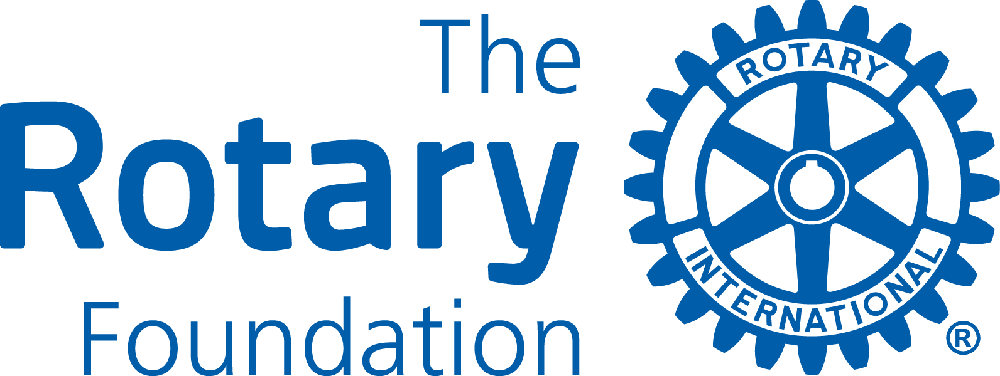

REPORT FORM
A Final Report is due two months after the completion of the project. Progress Reports are due every twelve months from receiving the District Grant cheque, until the Project is completed. Please note that Rotary and Rotarian also refer to Rotaract and Rotaractor throughout this document.

- GENERAL INFORMATION

Reporting Rotary Club
Project title
Area of Focus

Final Report Yes __ Progress Report Yes __

- PROJECT DESCRIPTION

Project Goal
Project Overview

Location
Project start/finish
Partners (if any)

Other information

- HOW WILL THIS PROJECT BENEFIT THE COMMUNITY?

Please, describe the benefits for the receiving community from this project.

- ROTARY/ROTARIAN/BENEFITTING COMMUNITY PARTICIPATION

Please, describe any non-financial participation by Rotarians, Rotaractors and members of the benefitting community. This may include needs assessment and partnerships developed, hands-on participation, and communication strategies to enhance the profile of Rotary, Rotaract and the Rotary Foundation

,
Estimated volunteer hours by Rotary/Rotaract members ______ Non-Rotarians ____

- PROJECT CONTACTS

Please, list the Project Committee members.

Contacts
Name (Prime)
Address
Phone/Email
Name
Address
Phone/Email
Name
Address
Phone/Email

- PROJECT BUDGET

 | Item/Supplier | Amount (CAD)
1
2
3
4
5
6
7
9
9
10
Total Project Budget

- SOURCES OF FUNDS

Total Project Funding
Source | Name of Clubs and other contributing sources | Amount (CAD)
Primary Club Cash
Other D7070 Clubs
Other Sources
District Grant Request
Total Project Funding

Please note, that Total Project Budget must equal Total Project Funding

Surplus funds must be returned to D7070. Are there any such funds for this project?
Yes ___ Amount in CAD ___________ No ___

- OWNERSHIP OF EQUIPMENT OR SUPPLIES

- Who will own equipment, materials, or supplies, once the project has been completed? (Rotary and Rotaract Clubs cannot own materials and supplies)

- Who will be responsible for future maintenance, operations and/or future costs for the equipment?

- ROTARY/ROTARACT BRANDING AND PUBLIC IMAGE

How will the general public know that this is a Rotary/Rotaract and Rotary Foundation project? Please, provide details about outreach to media (radio, TV, print & online), social media and how the Rotary Masterbrand Signature and the Rotary Foundation logo will be used on project materials and communications.

- CO-OPERATING ORGANIZATIONS

Please provide the name of any co-operating organization that may have cooperated in the project.

Name of Co-operating Organization/s

- AUTHORIZATION

- Progress and Final Reporting Requirements
The Primary Club is required to complete and submit progress and final reports to the District Grant Sub-Committee. Please, indicate below the individual (including contact information), who will be responsible for submitting the reports.

- Club President’s Authorization
As President of the Rotary Club of ___________________________________________________
I hereby affirm that the Club has voted to undertake this project as an activity of the Club

 | 11 a. Primary Club Contact | 11 b. Club President
Signature
Name
Date
Phone
Email

Please, submit your report with any attachments by email to
PDG Lars Henriksson, District Grant Sub-Committee Chair pdglars.henriksson@gmail.com

