 | Liability  GE0003 |  | 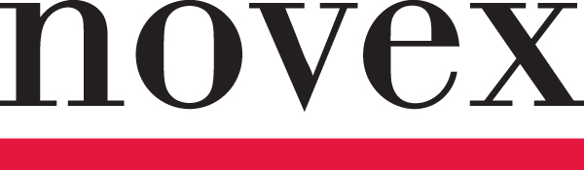

STAGE RENTAL, SET UP AND TAKE DOWN OPERATIONS – LIMITATION ENDORSEMENT

This Endorsement Changes the Policy. Please Read It Carefully.

Certain words and phrases that appear in bold have special meaning as defined below or in the Form to which this Endorsement is attached.
The titles of sections or paragraphs listed below should not be considered for purposes of interpreting the intent of this Form; these titles have only been inserted for ease of reading.
This Endorsement is attached to the Commercial General Liability Max Form and is subject to all terms, conditions, limitations and exclusions of such Form.
The following exclusion is added to SECTION 1 – COVERAGE A, 2. EXCLUSIONS:
This insurance does not apply to bodily injury or property damage arising from or caused by stage rental, stage set-up or stage takedown operations.
This exclusion does not apply to liability arising out of the use or operation of a stage(s) rented by and for the Named Insured’s sole use, provided that:
- the stage rental company supplying such property has provided the Named Insured evidence of General Liability Insurance with Limits of Insurance no less than $2,000,000; and
- the Named Insured is an additional insured on the aforementioned insurance policy.
Our liability is limited as follows:
The Limit of Insurance applicable to this Endorsement is $1,000,000 in the aggregate and is the most we will pay in any one policy period. This limit is part of, and not in addition to the Each Occurrence Limit shown in the Declaration Page(s).
In no event shall this policy insure against liability arising from rental of stages to others by or on behalf of the Insured.

All other terms and conditions of the Policy remain unchanged.

