 | Liability  GE0005 |  | 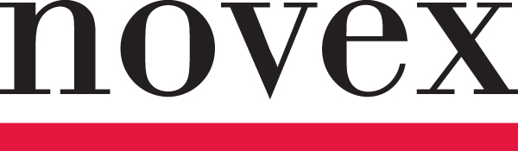

LIQUOR LIABILITY EXCLUSION

This Endorsement Changes the Policy. Please Read It Carefully.

Certain words and phrases that appear in bold have special meaning as defined below or in the Form to which this Endorsement is attached.
This Endorsement is attached to the Commercial General Liability Max Form and is subject to all terms, conditions, limitations and exclusions of such Form.
Notwithstanding any contrary provisions contained in this Policy, this insurance does not apply to bodily injury, property damage or personal injury for which any Insured may be held liable as a result of providing and/or serving or selling alcoholic beverages, except this exclusion shall not apply to rotary sponsored fund raising and/or rotary social events.

All other terms and conditions of the Policy remain unchanged.

