Rotary Toronto Eglinton Luncheon Meeting: Climate Change
Date: Nov 29, 2023, 12:00 PM for a 12:15 PM start
Topic: Climate Change: While Nations Talk, Cities Act
Speaker: David Miller, C40 Centre for City Climate Policy, and Economy
Format: Zoom
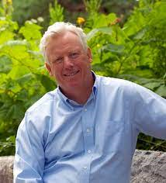
David Miller is the Managing Director of the C40 Centre for City Climate Policy and Economy.
Mr. Miller was Mayor of Toronto from 2003 to 2010 and served as Chair of C40 Cities from 2008 until 2010. Under his leadership, Toronto became widely admired internationally for its environmental leadership, economic strength, and social integration. He is a leading advocate for the creation of sustainable urban economies.
David Miller is a Harvard-trained economist and professionally is a lawyer.

Registration: To attend this meeting, you will need to register in advance. Those registered will receive the meeting link closer to the date. Please register at:

https://portal.clubrunner.ca/1159/Event/rotary-lunch-meeting-25

