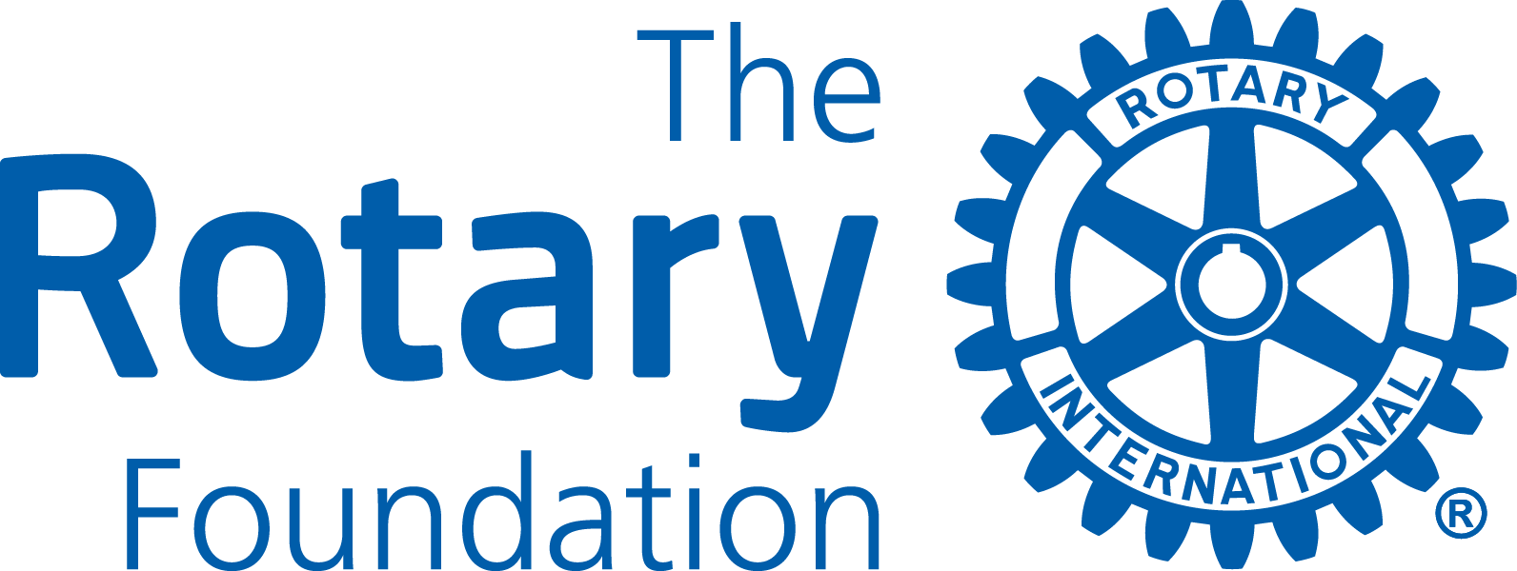

application form
Please, read the instructions at the end of this document as there are some changes compared to previous years. Rotary and Rotarian also refer to Rotaract and Rotaractors throughout this document. Please, type the information you enter.

GENERAL INFORMATION

Applying Rotary Club
Project Title
Area of Focus
Has final reports for any previous District Grants been submitted and accepted? | Yes  No
Is the Club qualified for the 2024-25 Rotary year? | Yes
The Club Has entered its goals in Rotary Club Central for 2024-25? | Yes

2. project descriPtion
Overview/Goal
Location
Partners (if any)
Project start/finish
Other information

3. How will this project benefit the community?
Please describe the benefits for the local and/or international community from this project.

4. Rotarian/rotaractor participation
Please describe any non-financial participation by Rotarians/Rotarcators in the project, including an estimate of volunteer hours. This might include needs assessment and partnership development, hands-on participation, and communication strategies to enhance the profile of Rotary, Rotaract and The Rotary Foundation.

Estimated volunteer hours in the project by Rotarians/Rotaractors

5. Project Contacts
The Primary (applying) Club must appoint a committee of at least three members from the Club to oversee the project. The committee members must be committed for the duration of the grant process. Please provide the mailing and email address for all committee members. The primary contact will receive all official communication from District 7070 and should share this information with the other committee members.

Contacts
- Name
- Address
- Phone/email
- Name
- Address
- Phone/email
- Name
- Address
- Phone/email

6. Project budget
 | Item/Supplier | Amount (CAD)
Total
Any unused District Grant (DDF) funds at the completion of the project must be returned to the District.

7. sources of funds
Projects with two or more Clubs that are fully financed on May 31, 2024, will be given priority by the District Foundation Grant Sub-committee when reviewing submitted project applications. Please, enclose confirming documents from supporting Clubs to the application.
Total Project Budget
Project Financing  - Primary Club Cash  - Other D7070 Clubs (please list clubs & cash contributions)  - Other, please specify  - District Grant request | Club and other supporting organizations Amount (CAD)  District Grant Request  Total Budget

8. OWNERSHIP OF EQUIPMENT OR SUPPLIES
a. Who will own equipment, materials, or supplies? (Rotary/Rotaract Club cannot own materials and supplies)

b. Who will be responsible for maintenance, operation, and/or future cost of the equipment/supplies?

9. rotary/ROTRACT BRANDING & Public image
How will the general public know this is a Rotary/Rotaract and/or Rotary Foundation sponsored project? Please provide details about outreach to media outlets (television, print & online), social media promotions, and how the Rotary Masterbrand Signature and the Rotary Foundation logo will be used on project materials and communications.

10. co-operating organizations
If the project involves a co-operating organization, please provide the name of each organization below and attach a letter of participation from the organization that specifically states its responsibilities and how Rotarians will interact with each organization in the project. By signing this application, the Rotarian sponsor endorses the organization as reputable, responsible, and acting within the law.
Name(s) of Co-operating Organization(s):

11. authorization
11a. Progress and Final Reporting Requirements
The Primary Club is required to complete and submit progress and final reports to the District Grant Sub-Committee. Please indicate below the individual (incl. contact information), who will have primary responsibility for submitting these reports.
11b. Club President’s Authorization
As President of the Rotary/Rotaract Club of
I hereby affirm that the club has voted to undertake this project as an activity of the club.
 | 11a. Primary Club Contact | 11b. Club President
Signature
Name
Date
Phone
Email

Please save the completed form

Submit your application by e-mail from March 1, 2024 up to May 31, 2024 to

PDG Lars Henriksson, D-7070 District Foundation Grant Sub-Committee Chair

pdglars.henriksson@gmail.com
NB Instruction pages are not required to be forwarded.
Proposals received by May 31, 2024 will be considered for the initial 2024-25 Spending Plan.

Instructions

District Grants are used to support short-term projects of individual Rotary/Rotaract clubs in District 7070. Clubs apply to the District 7070 Foundation Grant Sub-Committee which decides the merit of each application and the degree to which they will be funded. An application is not a guarantee for a grant!

The Rotary Foundation Terms & Conditions for District Grants
District Grant projects must comply with the Terms and Conditions of The Rotary Foundation District Grants, including the relating to the mission of the Rotary Foundation (see below). These terms and conditions are available on the District Grants page of the district’s website at www.rotary7070.org and at www.rotary.org.

The mission of The Rotary Foundation of Rotary International is to enable Rotarians to advance
world understanding, goodwill, and peace through the improvement of health,
the support of education, and the alleviation of poverty.

For complete rules and regulations for District Grants, please consult Terms and Conditions for Rotary Foundation District Grants (March 2023) which can be downloaded from Grant Resources at the Grant Center site on the Rotary Foundation https://grants.rotary.org/s_main.jsp?lang=1

District 7070 Grant Guidelines
- Projects must fall within one of the Rotary Foundation’s seven areas of focus:
  - Peace and conflict prevention/resolution
  - Disease prevention and treatment
  - Water, sanitation and hygiene
  - Maternal and child health
  - Basic education and literacy
  - Economic and community development
  - Environment and Sustainability
- Projects may take place anywhere in the world; however, a minimum of 25% of the District’s total District Grants funds will be allocated to projects in District 7070.
- Applications for District Grants in the 2024-25 Rotary year can be submitted from March 1, 2024, to the deadline May 31, 2024, to be considered and included in the District’s Spending Plan for approval by the Rotary Foundation for District Designated Funds (DDF).
- Applications received after May 31, 2024, may be considered if funds remain.
- The Primary (applying) Rotary/Rotaract Club in a project must be qualified for the 2024-25 Rotary year by May 31, 2024, according to The Rotary Foundation rules. Qualification is either completed online at www.rotary7070.org (under the Foundation menu), or by attending special workshop/seminars organized by the District.
- Applications must be for an original effort; recurring projects will not be considered for funding.
- The budget for a project must be a minimum of CAD1,000.
- To encourage Clubs in District 7070 to co-operate and create larger projects, the District will use the formula below to match every D7070 Club’s cash contribution of CAD in District Grant projects, subject to funds being available.
D7070 Clubs in the Project | 1-2 | 3-4 | 5 and more
Club Cash vs DDF (max) | 1 : 0.50 | 1 : 0.75 | 1 : 1
Max DDF/Club & Project (CAD) | 1,000 | 1,500 | 2,000
Max. DDF/Project (CAD) | 2,000 | 6,000 | 9,000

- The maximum amount that may be allocated to District Grant projects for the 2024-25 Rotary year is estimated to be the equivalent in Canadian dollars of USD85,000 (50% of new DDF), based on funds raised in the District for the Annual Fund of the Rotary Foundation three years ago.
- The District may decide to apply for less than the maximum allowed amount of DDF. However, at least up to CAD70,000 is expected to be set aside for District Grant projects.
- The actual amount of new DDF requested for District Grants from the Rotary Foundation by the District will be based on applications received by May 31, 2024, and other usage of DDF, e.g. contributions to PolioPlus and matching of Club Cash in Global Grant projects.
- District Grants can’t be combined with a Global Grant.
- Any unused District Grant funds allocated to a specific project must be returned to the District. This may occur for any number of reasons (e.g. the project does not happen, the project expenses are less than budgeted, fewer clubs participate etc.).
- An application is not a guarantee for receiving a District Grant.

District 7070 Evaluation Criteria
Proposals will be evaluated taking the following criteria into consideration.
- Primary Club qualified by May 31, 2024 The Primary (applying) Club must be qualified for the 2024-25 Rotary year by May 31, 2024. Sponsoring Clubs are encouraged to become qualified.
- Fully financed project applications will be prioritized. Project applications with more than one Club will receive priority if they can show by May 31, 2024,with supporting documents from sponsoring Clubs that the project is fully financed.
- Members’ hands-on involvement, where the degree of direct involvement by Rotarians/Rotaractors is considered.
- Impact of the project in the community, where among other things the demographic of the individuals being served is considered.
- Ability of a project to enhance the understanding and profile of Rotary/Rotaract and The Rotary Foundation in the community being served.
- Club co-operation, where clubs are encouraged to work together on projects.

Timelines for Applications, Project Execution & Reporting
- Submission Deadline - Applications for the 2024-25 Rotary year received by May 31, 2024 will be considered for the District’s application to The Rotary Foundation for a District Block Grant (Spending Plan) for the 2024-25 Rotary year.
- Review All applications received before the deadline will be reviewed by the District Grants Sub-Committee in June 2024. If total amount of funds for District grants exceeds the amount the District is allowed or intends to allocate for District Grants, the Committee will use various tools to allocate available funds among projects, such as lower the amount requested for every or some projects, select certain project applications, limit the number of projects per Club. The Committee will discuss this process with applying Clubs before making a final decision.
- Notification – The Committee aims to notify clubs of award decisions at the end of July 2024.
- Funds will be presented to successful Clubs as soon as they are received from The Rotary Foundation. The Lead Club for projects with two or more Clubs will receive all funds approved for that project.
- Project Execution - Clubs should strive to have projects completed by June 30, 2025.
- Reporting - A final report is due to the District Grant Sub-Committee no later than two months upon completion of a project. If a project lasts more than 12 months, a progress report must be submitted each 12 months until the project is completed. The District Grant report form is available at www.rotary7070.org.
- Documentation – Club reports and supporting documentation for all expenditures must be maintained by the Club for at least 5 years following closure of the grant.
- Promotion. Clubs are encouraged to present completed projects on websites, in social media, Rotary Showcase and other vehicles they may find useful.

