Rotary Leadership Institute (RLI) – We’re Zooming Again in 2022-23!
Posted by Susan Hunter, Chair District 7070 Rotary Leadership Institute
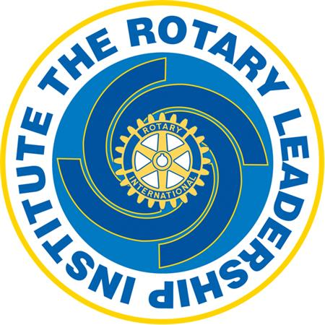

In 2022-23 we are staying with our Rotary Leadership Institute (RLI) programming in the virtual format. Although we all appreciate that videoconference will never replace the personal connection that we get from meeting face-to-face, RLI is a very successful program with overwhelming response and enthusiasm from Rotarians across the District. Rotarians new to Rotary and even those with many years of service benefit from learning how we can create strong clubs with vibrant members who are engaged and committed to Service Above Self.

Click here to register for Part 1 Wed Sept 14, Wed Sept 21, Wed Sept 28
Click here to register for Part 2 Wed Oct 12, Wed Oct 19, Wed Oct 26

Click here to register for Part 3 Wed Nov 9, Wed Nov 16, Wed Nov 23

One of the benefits of doing RLI virtually is that Rotarians from Rotary Clubs outside the Greater Toronto area were able to participate. In fact, we were joined by a few Rotarians outside our District which made for great conversations and interaction!

Here are some important details about the RLI program:
- There is $20 donation per person to be directed to the RI Foundation. This applies to each RLI courses.
- Attendance for each RLI course is limited to 25 people.
- Rotarians are welcomed to take RLI courses at another district by checking the Shining Waters Division website here.

THINK ABOUT 2022-23: ASK YOURSELF.... WHY SHOULD YOU ATTEND RLI?
Rotary provides an opportunity for all of us to provide service to our community and around the world. RLI has a mission to strengthen Rotary clubs through quality leadership education. As Rotarians, you are already a leader in your community and in your profession. The purpose of RLI is to give you the skills and competencies to be an effective leader in Rotary.

Rotarians new to Rotary and even those with many years of service will benefit from learning how we can create strong clubs with vibrant members who are engaged and committed to Service Above Self. Now more than ever, the world needs Rotarians to create a more peaceful and equitable world for all.

Rotarians can complete all three levels of the RLI program (Part I, II and III) within 3 weeks. In 2022-23, classes are scheduled on Wednesday evenings from 6:00 pm to 8:00 pm. There will be a Fall program in 2022 and a Spring program in early 2023.

Rotarians enjoy the learning and the interaction and dynamic conversation!

Editor's Note: Thank you to District 7070 RLI Chair Susan Hunter for another fantastic year.

For more information, please contact Susan Hunter at susan.hunter@rotarytoronto.com

