Rotary Leadership Institute (RLI) – We’re Zooming in the Fall Each Rotary Year!
Posted by Susan Hunter, Chair District 7070 Rotary Leadership Institute
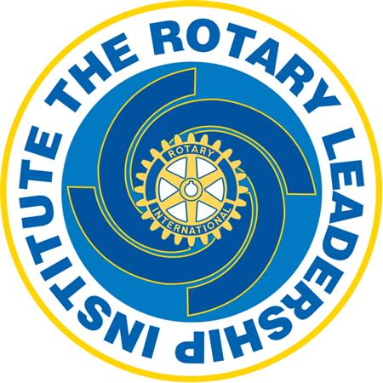

In the fall of each Rotary year, we are staying with our Rotary Leadership Institute (RLI) programming in the virtual format. Although we all appreciate that videoconference will never replace the personal connection that we get from meeting face-to-face, RLI is a very successful program with overwhelming response and enthusiasm from Rotarians across the District. Rotarians new to Rotary and even those with many years of service benefit from learning how we can create strong clubs with vibrant members who are engaged and committed to Service Above Self.

Details for the 2025-26 Fall sessions will be displayed here when they become available.

One of the benefits of doing RLI virtually is that Rotarians from Rotary Clubs outside the Greater Toronto area can participate. In fact, we were joined by a few Rotarians outside our District which made for great conversations and interaction!

Here are some important details about the RLI program:
- There is $20 donation per person to be directed to the RI Foundation. This applies to each RLI courses.
- Attendance for each RLI course is limited to 25 people.
- Rotarians are welcomed to take RLI courses at another district by checking the Shining Waters Division website here.

ASK YOURSELF.... WHY SHOULD YOU ATTEND RLI?
Rotary provides an opportunity for all of us to provide service to our community and around the world. RLI has a mission to strengthen Rotary clubs through quality leadership education. As Rotarians, you are already a leader in your community and in your profession. The purpose of RLI is to give you the skills and competencies to be an effective leader in Rotary.

Rotarians new to Rotary and even those with many years of service will benefit from learning how we can create strong clubs with vibrant members who are engaged and committed to Service Above Self. Now more than ever, the world needs Rotarians to create a more peaceful and equitable world for all.

In the Fall sessions , Rotarians can complete all three levels of the RLI program (Part I, II and III) within 3 weeks. Classes are scheduled on Wednesday evenings from 6:00 pm to 8:00 pm. There will be a Fall program announced for the fall and there will still be an In Person session each spring. Rotarians will be able to learn and interact with dynamic conversation!

Editor's Note: Thank you to District 7070 RLI Chair Susan Hunter for another fantastic year.
For more information, please contact Susan Hunter at susan.hunter@rotarytoronto.com

