## **Rotary District 7070 Youth Exchange Program**

[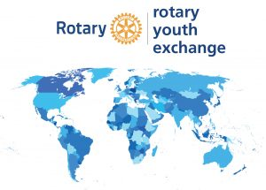](https://rotary7070.org/Committee/youth-exchange-3)

**Host Families Apply Here!**

Host families are the key to the success of youth exchange. Enjoy the benefits of learning about a different culture right from your home.  Shape the life of a young adult forever.  See below for eligibility guidelines.

Click here to apply[: https://yehub.net/cgi-bin/C07_get.cgi?pgid=aphf1](:%20https:/yehub.net/cgi-bin/C07_get.cgi?pgid=aphf1%20)

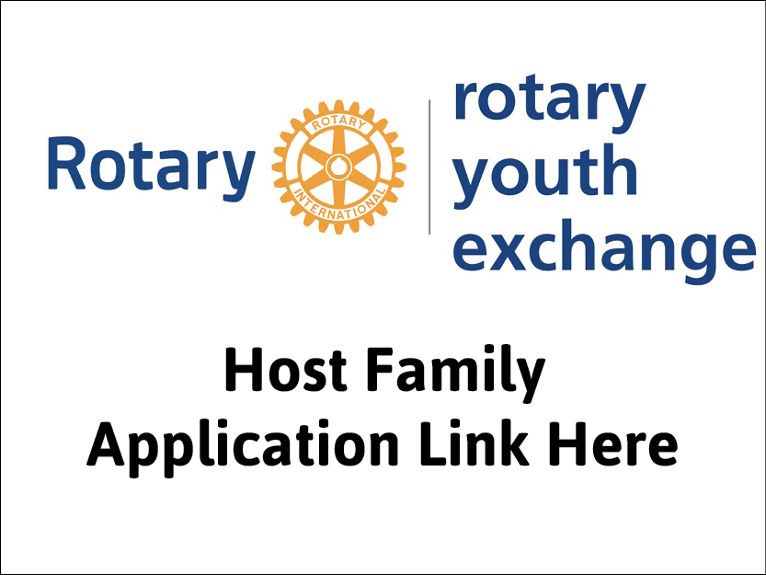

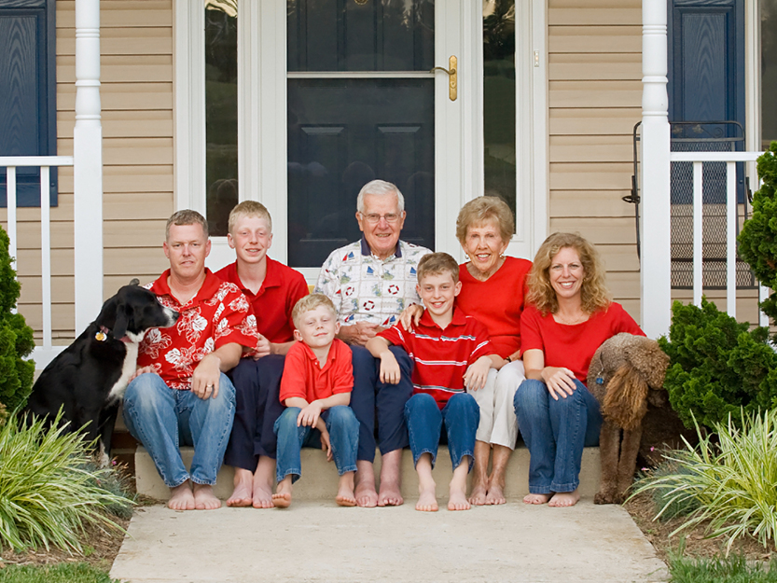

Are you an Eligible Host Family?

Eligible host families are:

* Married or common law couples
* Single parent families
* Homes with or without school age children
* Respected members of the community
* Background vulnerable sector check approved
* Reference checked (references provided by the applicant)
* Approved by a local participating YE Rotary club