Rotary Public Service Announcement Campaign

Alert your local media outlets to ads that show Rotary members as People of Action.

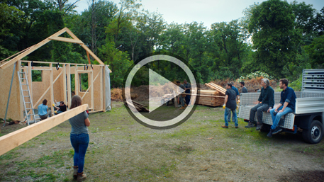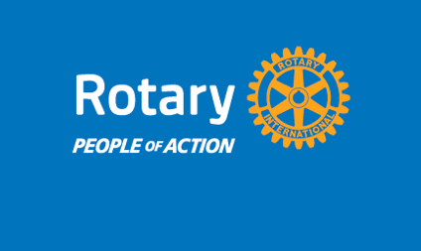
Raising public awareness

While many people have heard of Rotary, the majority of Americans don't understand who we are or what we do. The People of Action ads featured in the Public Service Announcement (PSA)
campaign can help bridge the gap between awareness and understanding by showing the public
real examples of Rotary clubs making a difference in communities here and around the world.

Leveraging an important tool

Unlike traditional advertising, PSAs are designed to educate and raise awareness of issues that are important to the public. They use donated ad space that is reserved for nonprofits, allowing organizations to gain valuable media exposure free of charge. Rotary will continue to leverage this important vehicle to build awareness and understanding of our brand and the impact we make.

Our PSA agency has distributed Rotary People of Action ads to over 1,700 local and network TV stations and 9,470 radio stations nationwide since the campaign launched in March 2020.

How you can participate

Contact PSA directors at your local TV and radio stations and ask them to include our Rotary PSA in their programming. They can access the campaign materials at the PSA Download Center.

Extend the PSA campaign by featuring People of Action ads on your club website and social media channels. Download People of Action ads and videos from the Brand Center or create your own.

Rotary Public Service Announcement Campaign
Frequently Asked Questions

When and where can I expect to see Rotary TV, radio, and magazine ads?
Media outlets run PSAs free of charge in their unsold advertising spaces, so we won't know in
advance where or when the ads will appear. However, once the ads run, we will receive reports on airings and placements that can be shared upon request.

What is the value of the donated media?
Since launching in March 2020, Rotary’s PSA campaign has reached millions of Americans through TV, radio, and print ads, with a total donated media value of $38.8 million and counting.

How can I get involved with the campaign?
You can get involved by contacting PSA directors at your local media outlets to let them know about Rotary's PSA campaign. Ask them to take action by including our Rotary PSAs in their programming.

Where should I direct PSA directors and program managers?
Media outlets can access all Rotary PSA campaign materials from the PSA Download Center.

Will these PSAs run on Rotary's social media channels?
Rotary will continue to share these People of Action ads with the general public on our social
media channels.

Where can I view the PSA materials?
Materials formatted for broadcast and print publications can be found on the PSA Download Center.

Materials formatted for club use can be found on the Brand Center.

Where should I direct my questions about the PSA campaign?
Please send any questions about the PSA campaign to PR@Rotary.org

