Rotary Club projects for Clean Water
6/7/2026 Ideas from David Winkelman, concerned conservationist and a Rotary Club Member in Brainerd MN.
Local Rotary clubs can have an enormous impact on water quality because the possible environmental projects are highly visible, community-oriented, and often easy to replicate. Below is a list of environmentally beneficial projects that are scalable, measurable, and duplicatable anywhere in the world, with special emphasis on cleaner water.
1. Community Water Testing Program
Train Rotary volunteers and students to monitor local lakes, rivers, streams, and groundwater.
Activities
- Test for nitrates, phosphates, bacteria, turbidity, pH, and dissolved oxygen.
- Publish results online and at community meetings.
- Partner with schools and universities.
Benefits
- Early pollution detection.
- Public awareness.
- Creates long-term environmental data.
Rotary Scale
- $500–$5,000 startup cost.
- Easy to duplicate worldwide.

2. Rain Garden Initiative
Help homeowners, schools, churches, and businesses install rain gardens.
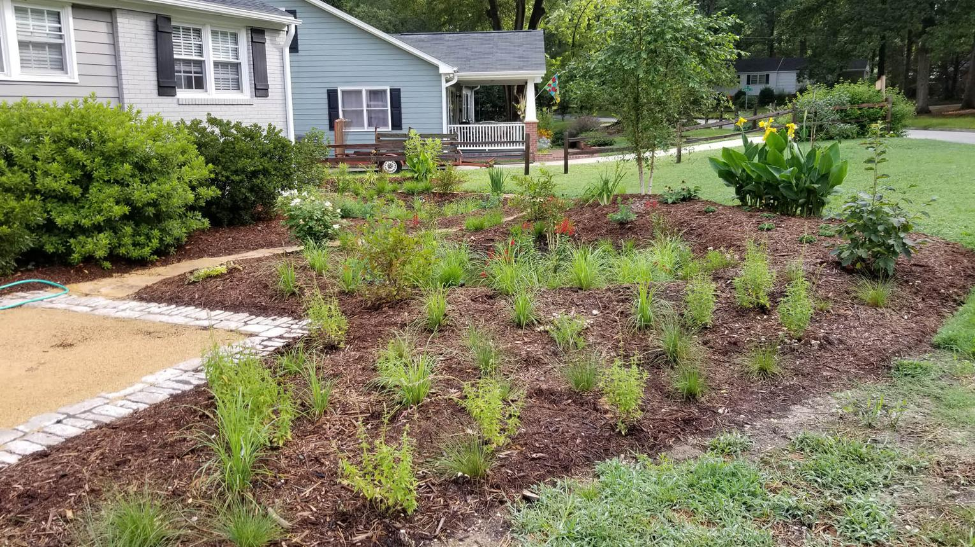
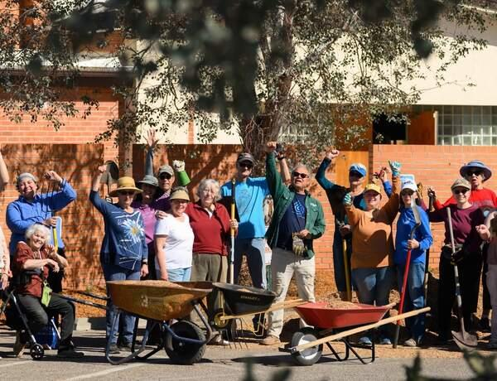
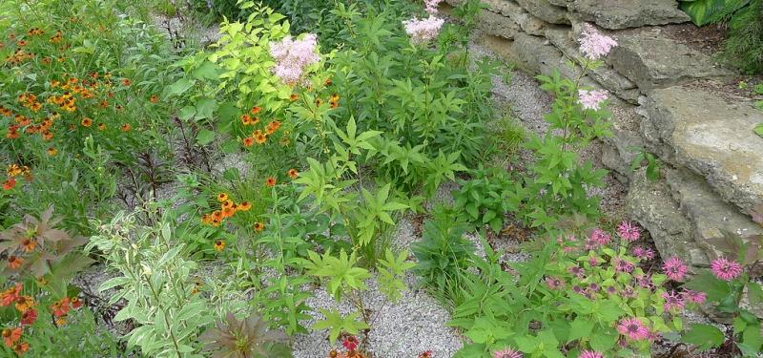
4
Benefits
- Reduces stormwater runoff.
- Filters pollutants before reaching lakes and rivers.
- Improves groundwater recharge.
- Provides pollinator habitat.
Rotary Scale
- One demonstration project each year.
- Create local "Rain Garden Champions."

3. Adopt-a-Stream or Adopt-a-Lake
Rotary clubs become long-term stewards of a local water body.
Activities
- Quarterly cleanups.
- Invasive species removal.
- Shoreline restoration.
- Water quality monitoring.
Benefits
- Immediate visible impact.
- Builds community ownership.

4. Septic System Education Program
One of the most overlooked water-quality projects.
Activities
- Free homeowner workshops.
- Septic inspection discounts.
- Septic maintenance reminder campaigns.
Benefits
- Reduces groundwater contamination.
- Prevents nutrient pollution.
- Protects drinking water wells.

5. Native Shoreline Restoration
Replace turf grass along lakes and rivers with native vegetation.
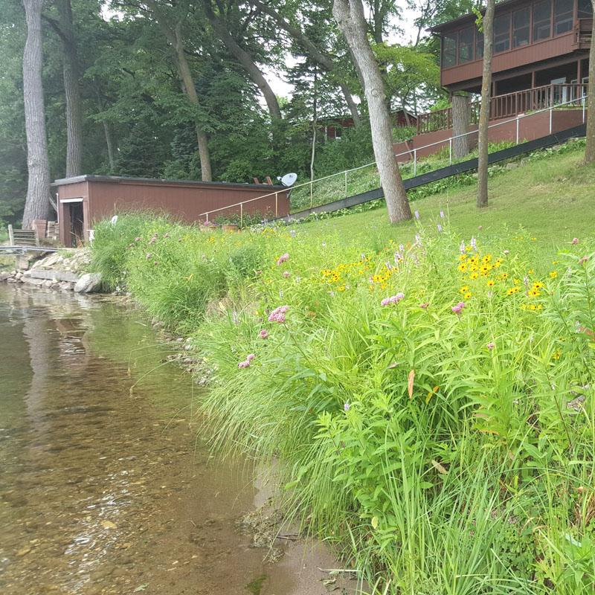
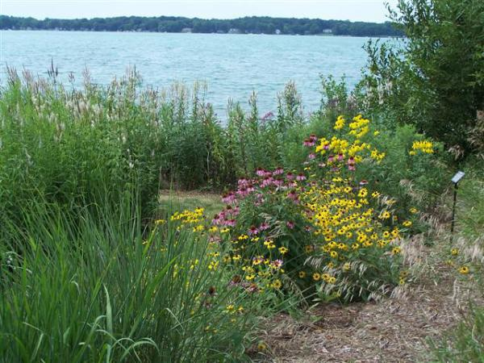
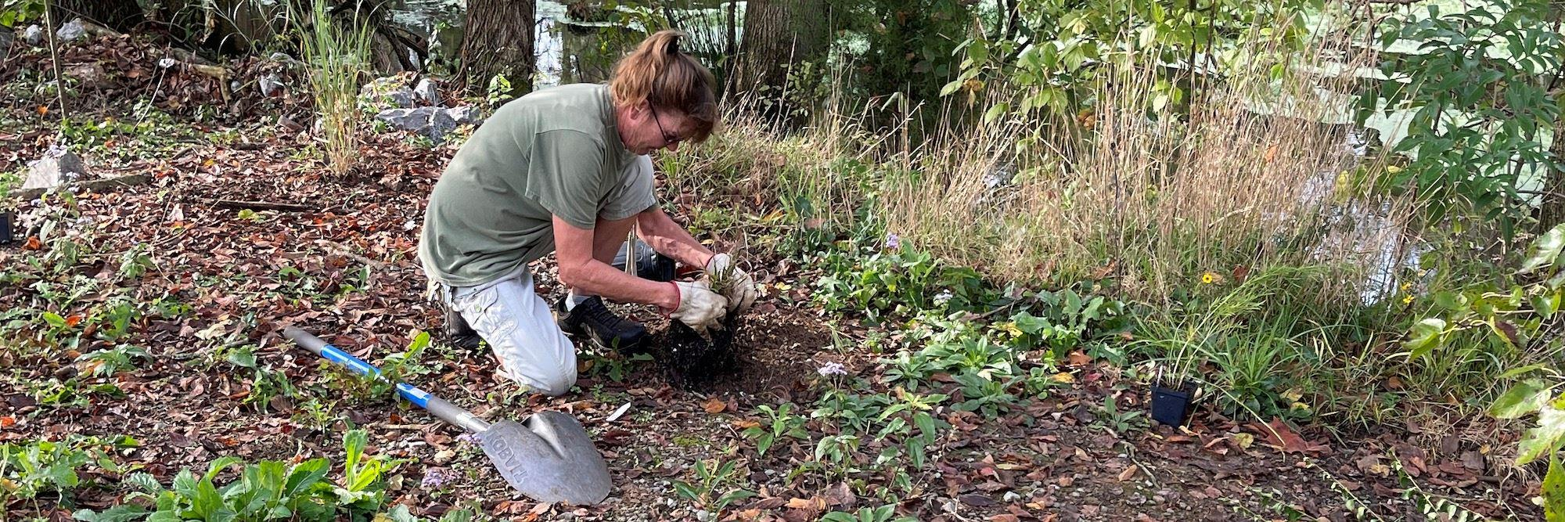
4
Benefits
- Reduces phosphorus runoff.
- Controls erosion.
- Improves fish habitat.
- Increases biodiversity.

6. School Water Stewardship Program
Create youth-led water projects.
Examples
- Water testing clubs.
- Rain barrel installations.
- School rain gardens.
- Watershed science projects.
Benefits
- Long-term community impact.
- Creates future environmental leaders.

7. Community Rain Barrel Program
Bulk purchase and distribute rain barrels.
Benefits
- Reduces runoff.
- Conserves water.
- Easy public participation.
Rotary Model
- Sell at cost or donate to low-income households.

8. Wetland Restoration Partnerships
Partner with conservation agencies to restore degraded wetlands.
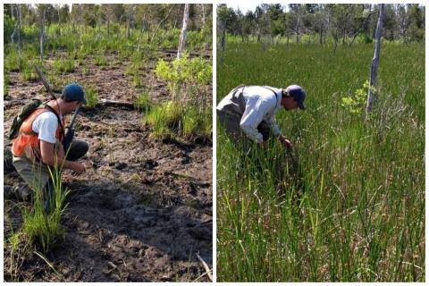
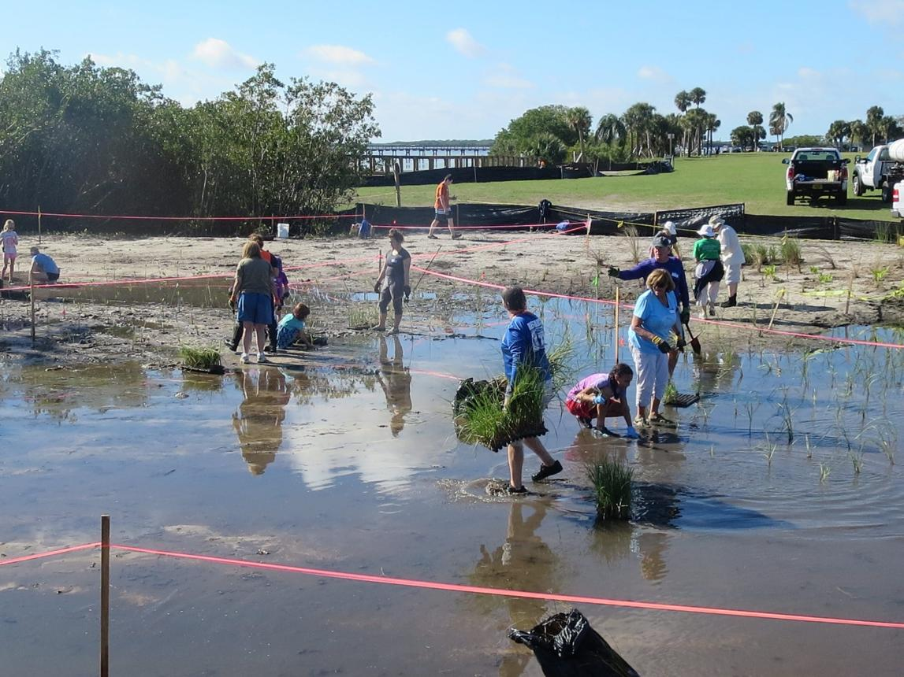
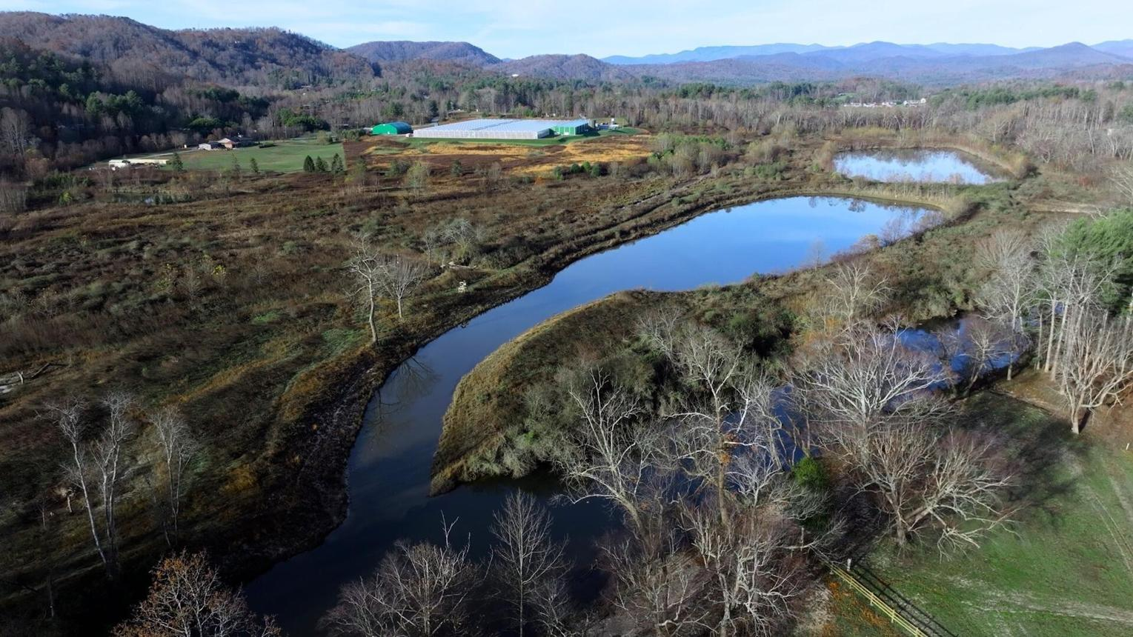
8
Benefits
- Natural water filtration.
- Flood reduction.
- Wildlife habitat.
- Carbon sequestration.

9. Watershed Education Signs
Install educational signage near lakes, streams, and storm drains.
Messages
- "Only Rain Down the Drain."
- Fertilizer reduction.
- Pet waste disposal.
- Shoreline protection.
Benefits
- Very low cost.
- Long-lasting impact.

10. Rotary Drinking Water Kiosks
Especially valuable in developing countries.
Activities
- Digging new wells
- Solar-powered purification systems.
- Community water kiosks.
- Water ATM systems.
Benefits
- Safe drinking water.
- Reduced disease.
- Sustainable local management.

11. Well Rehabilitation Projects
Many communities have abandoned or contaminated wells.
Benefits
- Provides clean water.
- Less expensive than drilling new wells.
- Excellent international Rotary project.

12. Plastic-Free Waterways Campaign
Reduce plastics entering rivers and oceans.
Activities
- Community cleanups.
- Reusable bottle campaigns.
- School education.
Benefits
- Improved water quality.
- Wildlife protection.

13. Storm Drain Marking Program
Install markers reminding residents that storm drains flow directly to waterways.
Benefits
- Reduces dumping.
- Very inexpensive.
- Easy youth project.

14. Agricultural Buffer Strip Program
Partner with farmers.
Activities
- Native grass strips.
- Pollinator buffers.
- Riparian buffers.
Benefits
- Reduces sediment.
- Reduces phosphorus and nitrogen runoff.
- Improves wildlife habitat.

15. Community Tree Planting for Water Quality
Trees are water infrastructure.
Benefits
- Reduce runoff.
- Improve infiltration.
- Reduce stream temperatures.
- Prevent erosion.

16. Rotary Watershed Mini-Grants
Provide small grants ($500–$5,000) to schools, nonprofits, and neighborhood groups.
Eligible Projects
- Rain gardens.
- Shoreline restoration.
- Water monitoring.
- Pollinator habitat.

17. Water Conservation Challenge
Community competition for reducing water use.
Activities
- Rain sensors.
- Efficient irrigation.
- Leak detection.
- Low-flow fixtures.
Benefits
- Conserves drinking water supplies.

18. Rotary "Blue Community" Certification
Create a local recognition program.
Requirements
- Water conservation.
- Pollution reduction.
- Native landscaping.
- Reduced fertilizer use.
Communities compete for annual Rotary recognition.

19. Solar-Powered Aeration for Lakes and Ponds
Useful where algae blooms are increasing.
Benefits
- Improves oxygen levels.
- Reduces fish kills.
- Demonstrates renewable energy.

20. Global Rotary Clean Water Network
A highly duplicatable model.
Components
- Standardized water testing.
- Shared data platform.
- Annual reporting.
- Friendly competition among clubs.
This could become a signature Rotary environmental initiative worldwide.
Top 5 Rotary Water Projects Most Easily Replicated Worldwide
- Community Water Testing Program
- Rain Garden Initiative
- Adopt-a-Stream/Lake Program
- Septic System Education Campaign
- School Water Stewardship Program
These projects are relatively inexpensive, volunteer-friendly, measurable, and directly support Rotary's focus area of providing clean water while improving local environmental quality. For a Rotary club in Minnesota, especially around lake communities, shoreline restoration, septic education, water monitoring, and rain gardens typically provide the greatest water-quality improvement per dollar invested.

Signature Vision: Introducing Bog Frog

The strongest long-term concept is to make Bog Frog the environmental equivalent of Smokey Bear—a recognizable conservation mascot that teaches one simple lesson:
Healthy frogs mean healthy water. Healthy water means healthy communities.
Rotary clubs around the world could then adopt a common, easily replicated framework under the banner:
The Bog Frog Clean Water Initiative
with local projects focused on water testing, shoreline restoration, wetlands, septic stewardship, stormwater management, and environmental education. This gives every project a memorable face while keeping the mission centered on clean water and conservation.
"Bog Frog" is an excellent mascot because frogs are universally recognized as indicators of clean water, healthy wetlands, and thriving ecosystems. A frog character can connect children, families, landowners, businesses, schools, Rotary clubs and conservation professionals around a common message.
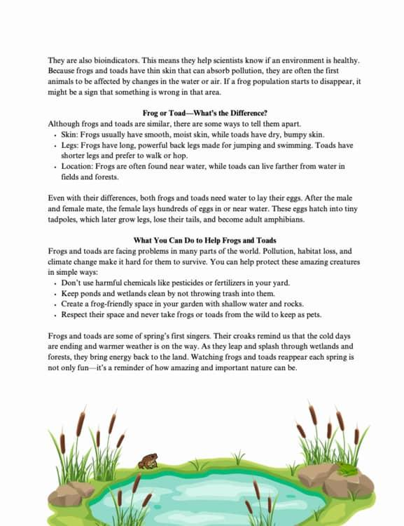
"What's good for Bog Frog is good for our water."

Bog Frog Brand Identity
Character
Bog Frog
- Wise but fun
- Loves clean water
- Lives in wetlands, trees, lakes, streams, and ponds
- Travels the world helping communities protect water
Motto Options
- “Conservation Pays!”
- “Reduce, Reuse, Recycle”
- "Keep Water Hopping Healthy!"
- "Every Drop Matters a tad."
- "Protect Our Watershed."
- "Clean Water Starts Here."
- "Be Frog Friendly."

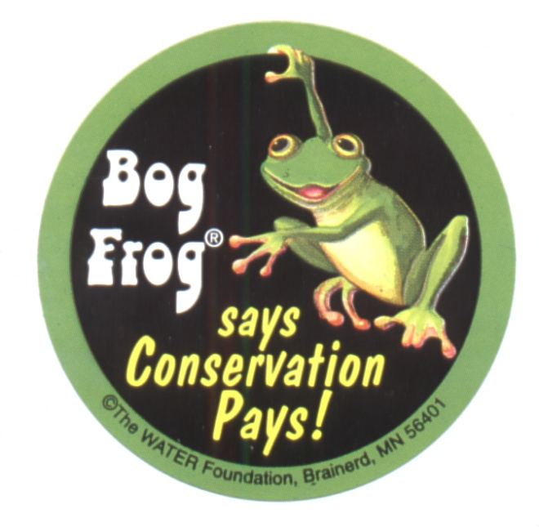
Program and Project Ideas with Bog Frog. Bog Frog is an internationally recognized icon for clean water. Frogs are like the canary in the coal mines for water. Any and all of the above programs can work with Bog Frog. Here are examples of some of them:

1. Bog Frog Water Guardians
For water-testing programs.
Children and volunteers become:
Certified Bog Frog Water Guardians
Participants receive:
- Badge
- Patch
- Lapel pin, Hat pin or solar powered toy frog
- Water testing certificate
Levels:
- Tadpole Guardian
- Froglet Guardian
- Bog Frog Master Guardian

2. Bog Frog Shoreline Challenge
For lake and river restoration.
Property owners earn recognition by:
- Planting native species
- Reducing fertilizer use
- Restoring shoreline buffers
Recognition:
- Bog Frog Yard Sign
- Annual awards
Example:
"Bog Frog Approved Shoreline"

3. Bog Frog Rain Garden Program
Every rain garden becomes:
"A Bog Frog Home"
Participants receive:
- Garden sign
- Native plant guide
- Frog habitat information
Schools can build:
- Bog Frog Learning Gardens

4. Bog Frog Septic Steward Campaign
Perfect for Minnesota lake communities.
Message:
"Bog Frog Can Croak from Leaky Septics."
Campaign materials:
- Refrigerator magnets
- Pumping reminders
- Septic maintenance checklists
Annual event:
Bog Frog Septic Check-Up Month

5. Bog Frog Adopt-a-Lake
Each participating Rotary Club adopts:
- A pond
- Stream
- Wetland
- Lake
Volunteers become:
Bog Frog Lake Keepers
Activities:
- Litter removal
- Water sampling
- Habitat restoration

6. Bog Frog School Program
This may become the most powerful program.
Elementary curriculum:
Adventures of Bog Frog
Topics:
- Water cycle
- Pollution prevention
- Wetlands
- Wildlife habitat
Students earn:
- Bog Frog Explorer certificates

7. Bog Frog Rain Barrel Program
Rain barrels decorated with:
Official Bog Frog Artwork
Slogan:
"Catch the Rain Before It Runs Away."
Families collect stickers for participation.

8. Bog Frog Wetland Rescue Project
For wetland restoration efforts.
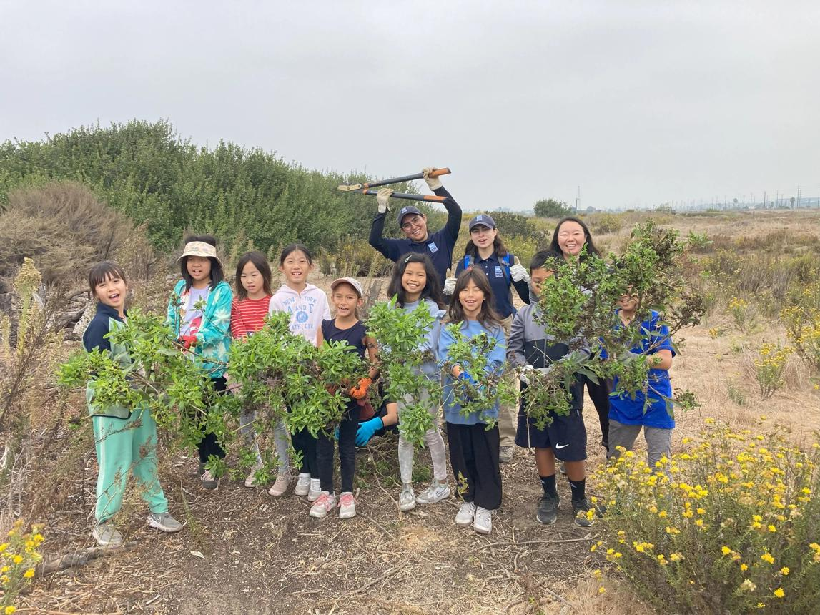
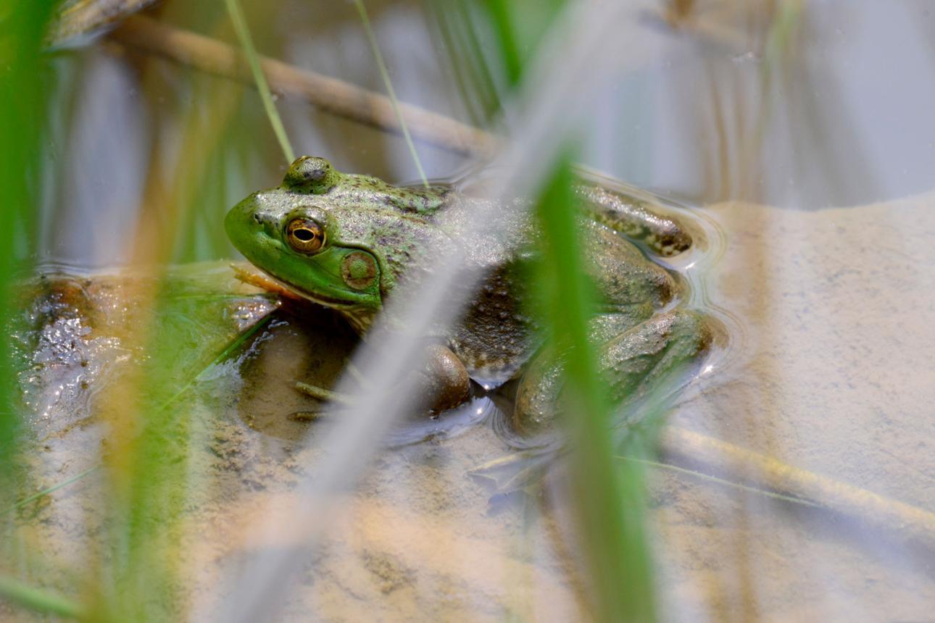
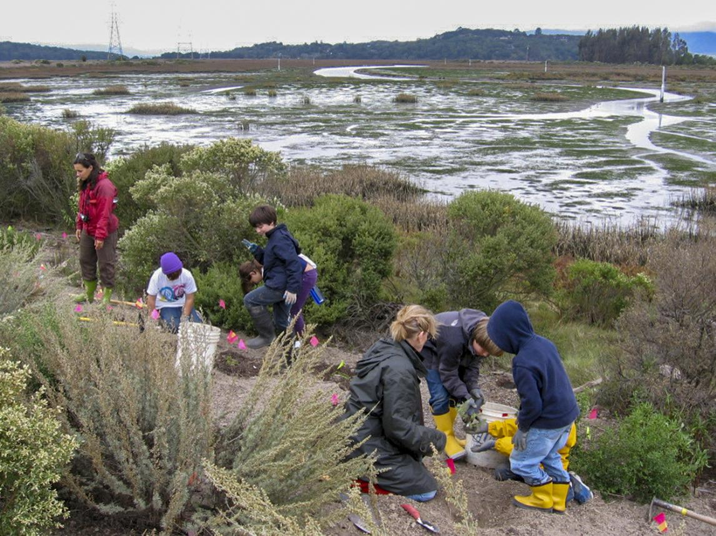

Each restoration site becomes:
A Bog Frog Habitat
Signage explains:
- Water filtration
- Flood reduction
- Wildlife benefits

9. Bog Frog Storm Drain Marking
Every storm drain receives:
"This Drain Leads to Bog Frog's Home"
Simple visual message:
- No dumping
- Protect lakes
- Protect streams
Very low cost and highly visible.

10. Bog Frog Community Tree Program
Trees become:
Bog Frog Shade Trees
Educational message:
Trees help keep streams cool for fish, frogs, and wildlife.

11. Bog Frog Water Festival
Annual Rotary event.
Activities:
- Water testing demonstrations
- Native plant sales
- Rain barrel sales
- Children's games
- Environmental exhibitors
Featured character: Bog Frog
Could become a signature Rotary event.

12. Bog Frog “Water Passport” Program
Participants collect stamps by completing activities:
- Attend a cleanup
- Test water
- Plant natives
- Install rain barrel
- Restore shoreline
Rewards:
- Frog Friendly Stickers
- Pins
- T-shirts

13. Bog Frog Global Rotary Network
A worldwide Rotary environmental initiative.
Clubs report on many programs and projects:
- Trees planted
- Rain gardens built
- Water samples collected
- Shoreline restored
- Wells drilled
Recognition levels:
- Bronze Bog Frog Club
- Silver Bog Frog Club
- Gold Bog Frog Club
- Platinum Bog Frog Club

14. Bog Frog Business Certification
Businesses earn recognition for:
- Water conservation
- Stormwater management
- Native landscaping
- Pollution prevention
Display:
Bog Frog Water-Friendly Business

15. Bog Frog Citizen Science App
Volunteers report:
- Frog sightings
- Algae blooms
- Water clarity
- Invasive species
Data helps local conservation groups and schools.

Bog Frog Merchandise That Supports Projects
Fundraising items:
- Plush frogs, solar frogs
- Children's books
- Coloring books
- Stickers
- Patches
- Trading pins
- Yard signs
- Water bottles
- Rain gauge kits

Signature Vision
The strongest long-term concept is to make Bog Frog the environmental equivalent of Smokey Bear—a recognizable conservation mascot that teaches one simple lesson:
Healthy frogs mean healthy water. Healthy water means healthy communities.
Rotary clubs around the world could then adopt a common, easily replicated framework under the banner:
The Bog Frog Clean Water Rotary Initiative
with local projects focused on water testing, shoreline restoration, wetlands, septic stewardship, stormwater management, and environmental education. This gives every project a memorable face while keeping the mission centered on clean water and conservation.

