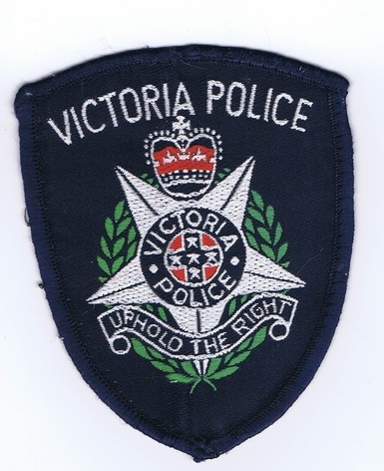
VICTORIAN POLICE LEADERS MENTORING PROGRAM

SELECTION OF POLICE PARTICIPANTS

The process for selection of police members is as follows:

Police Command (Assistant Commissioners and equivalent) identify senior sergeants who have the potential to develop by participating in the program. This generates a pool of about 45, who are invited to attend a briefing session.

These officers are invited to apply for the program, and 25 to 30 may do so. Applications are then short listed and interviews are held, after which a recommended list is sent to the Assistant Commissioner, People Development Command for their approval.

So, it is very much a police process, although some potential candidates may approach their local club to discuss project ideas when putting together their applications.

The next round of recruitment for Rotary mentors will start in March / April 2023.

The closing function for the current cohort will be held in May 2023. It is usually a breakfast function at the RACV Club in Melbourne.

