VOCATIONAL SERVICE AT WORK
ROTARY TEACHERS’ AWARDS
Several weeks ago, the Principal of a local primary school was guest speaker at my Rotary club. He spoke about the challenges faced during the pandemic lockdowns, by students, families and the teachers, and the on-going issues resulting from this major disruption to student learning.
He also spoke about the pressure and demands placed on the teachers dealing with home schooling, and then the return to classrooms where many students are still unsettled and unable to focus.
The principal praised those teachers who are also parents, as they had to monitor the home schooling for their own children, while teaching perhaps 25 other children, some with little or no family support.
The teachers with no children of their own, who may live on their own, found the isolation difficult, and often chose to work at the school. Although the school had rostered days for staff to attend, some of these teachers were on the premises almost every day.
Much of this is familiar to everyone, especially those people who had to cope with home schooling, as well as working from home.
However, for many teachers, the impacts of the Covid lockdowns are far from over. The principal emphasised that, at the moment, the two primary focuses of his school are re-building social connections and relationships, and getting students physically active again, after several years of restricted movement and play. It may take a long time before school staff and students feel that things are ‘back to normal’.
And so …… at this stage in the Covid journey, perhaps it is an excellent time to acknowledge the fantastic work of so many dedicated teachers in our schools.
Through Vocational Service we:
1. Serve Others by using our unique skills to address community needs
2. Empower others through training and skill development
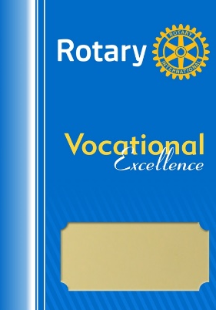
Establishing a Teachers’ Awards Program enables Clubs to meet the third aspect of Vocational Service:
3. Inspire Others to act with integrity by following Rotary’s guiding principles.

OBJECTIVES
• Recognise and honour outstanding performance in local schools (both as individuals and teams).
• Encourage early career stage teachers (eg. 1st year teachers), experienced teachers, and outstanding teamwork in Schools.
• Open opportunities for increased collaboration between Rotary and Schools, increase Rotary visibility, attract new members.

GENERAL APPROACH
• Invite local schools to nominate Teachers and/or support staff to be recognized at an event organized and hosted by Rotary.
• Rotary Vocational Service Award Certificates to be presented to successful nominees at the event by Local Mayor, Dignitary or Rotarian.
• Event to be promoted to local media and via Rotary Club Newsletters & Website.

POSSIBLE AWARD CATEGORIES
• Encouragement Awards: for early career stage teachers.
• Achievement Awards: for more experienced teachers.
• Team Awards: where a group of teachers have collaborated effectively to
address an important challenge or new development for a school.

Half way through Term 3 is an excellent time to consider an awards program for teachers in your local area. The awards could be presented at a special event towards the end of the school year, acknowledging the efforts and achievements of teachers throughout the past three years of the pandemic, or they may just be for 2022.
If your club is considering this excellent Vocational Service Award, additional information will be available on the District 9790 website. If you cannot access this site, please send me an email and I will forward it to you.
I would like to acknowledge Rotarians from District 9800 who have allowed me to access ideas and material from their Vocational Service website. Their Teacher Awards were introduced by D9800 PDG Julie Mason AM, and have been very successful in many of their clubs.
Lorraine Greenwood
District 9790
Vocational Service Chair (2022-2023)

