Fundraising to support Yelizaveta Navrotska, our inbound Rotary Youth Exchange student from Ukraine.
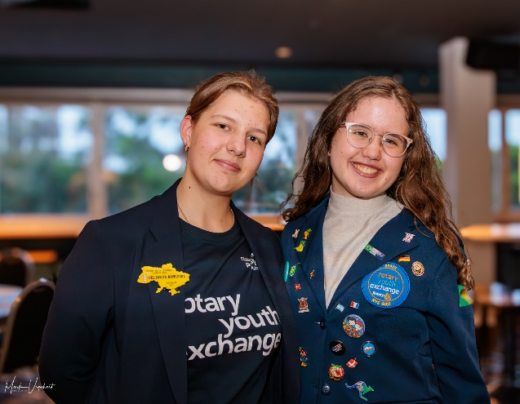
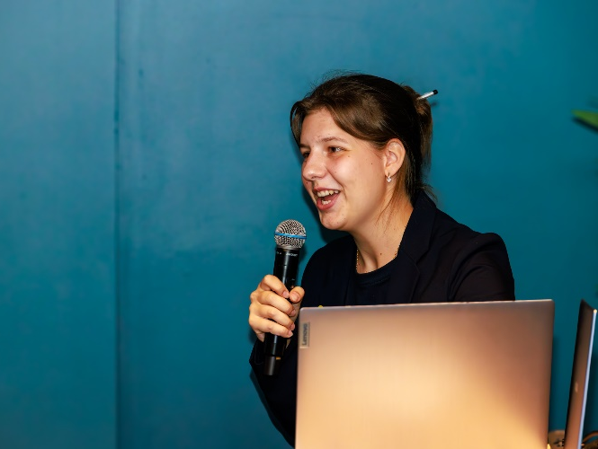
To: Rotary Clubs of District 9640
In January this year our district welcomed a youth ambassador, Yelizaveta Navrotska, on a one-way Rotary Youth Exchange from Kyiv in Ukraine. We often talk about ‘Building world peace, one student at a time’ being the core mission of the youth exchange program, fostering cultural understanding and goodwill among nations. Never has that been more appropriate than in this moment with this student.
Yelizaveta is being co-hosted by the Rotary Clubs of Coomera River and Ashmore and has been awarded a scholarship to attend Trinity College at Ashmore. This exchange presents an incredible chance for her to experience Australian life and develop as a future leader, while also allowing us, to increase our understanding of Ukraine and its people, both before and during the war.
Today we are reaching out to you to ask for your assistance in making this exchange possible. The exchange, totalling approximately $18k, is being fully funded by Rotary in District 9640 to help support Yelizaveta’s parents who are still in Ukraine with Yelizaveta’s two siblings. Is your club in a position to make a small contribution to Yelizaveta’s exchange so we can reach our remaining fundraising target? You contribution, no matter the size, will go directly towards ensuring that Yelizaveta's experience in Australia is enriching and memorable. If you are able to donate, please email yep@rotary9640.org
We extend our deepest gratitude to those clubs and individuals who have already generously donated towards Yelizaveta's exchange.
Thank you for your unwavering dedication to Rotary’s mission and for considering this request among the many requests you receive for financial support. Together, let’s make Yelizaveta’s exchange in Australia a resounding success.
Yours in Rotary Service

DG Dave Harmon Kathryn Koch
D9640 District Governor 2023/24 Chair, D9640 rotary Youth Exchange

