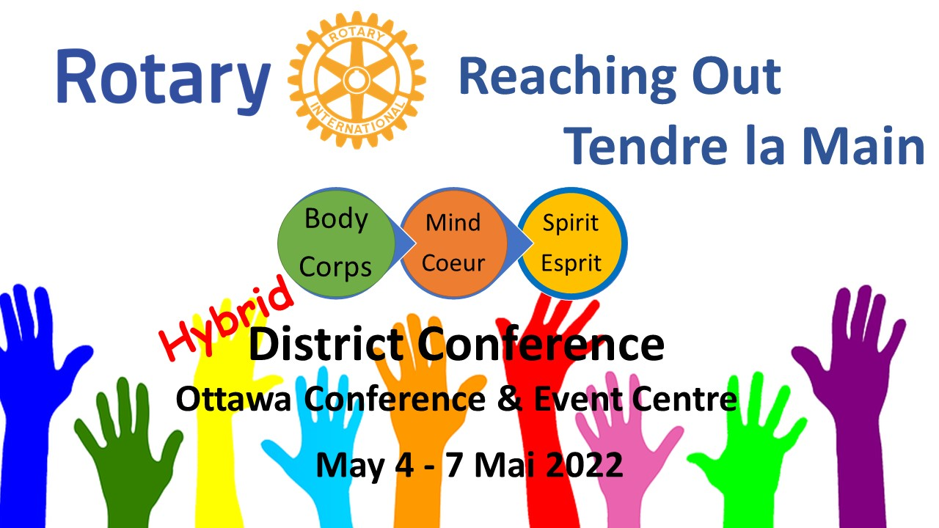

District Conference 2022 – ‘Reaching Out’
SPONSORSHIP OPPORTUNITIES

Join with Rotary in promoting the importance of mental health
& well-being, and building resiliency, especially for youth.

May 4-7, 2022
Online & Ottawa Conference & Event Centre
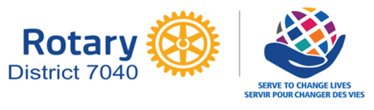

23 February 2022 v2.8
Dear Rotarian or friend of Rotary,
Rotary International is one of the oldest and largest service organizations in the world. It’s an active network of community-minded people who believe in supporting worthwhile causes – and like-minded organizations. If your organization is interested in reaching this audience in a meaningful way, while supporting important work to improve our community, read on.

Rotary District 7040 Conference 2022 – ‘Reaching Out’ offers several structured sponsorship opportunities for our online and onsite event being held May 4-7 2022 in a hybrid virtual and in person at The Ottawa Conference & Event Centre, 200 Coventry Rd. Ottawa Ontario.

Rotary Reaching Out: Body, Mind & Spirit is the theme of this year’s conference. The Conference coincides with Mental Health Week in Canada and the focus on health & well-being - with an emphasis on youth well-being, will be central to Rotary District 7040 Conference 2022 – Reaching Out. We will describe the mental health landscape and then provide strategies to cope and ideas on how Rotary can help.

Like previous district conference gatherings, supporters and key contributors will gain valuable exposure and a direct link to Rotarians (and their networks) from 70 clubs located in two provinces, one territory, and one state. Benefit from on-site promotion at the conference from signage, mini-booth and pre-session announcements to online website, social media and direct club member communication. There are many options for you to effectively get your message out to our membership and conference attendees… you simply have to choose the best fit!

We look forward to partnering with you.
Yours in Rotary;
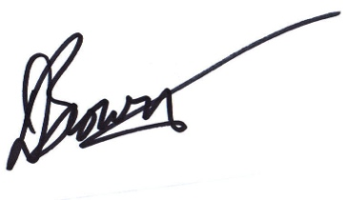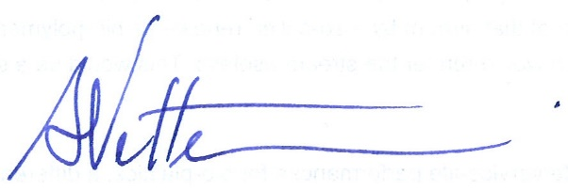
Dwight Brown & Scott Vetter, Co- Sponsorship Chairs
Rotary 7040 District Conference 2022

District Conference 2022 – Reaching Out: Sponsorship Opportunities

Fittingly, after two years of coping with the COVID pandemic, the theme for our annual conference in May 2022 is Reaching Out: Body, Mind and Spirit. Rotary is constantly reaching out to help others, and will play a role as everyone is ready to restart their lives, to reach out and connect. The conference will be held in person giving you an intimate setting to connect with those attending that weekend.

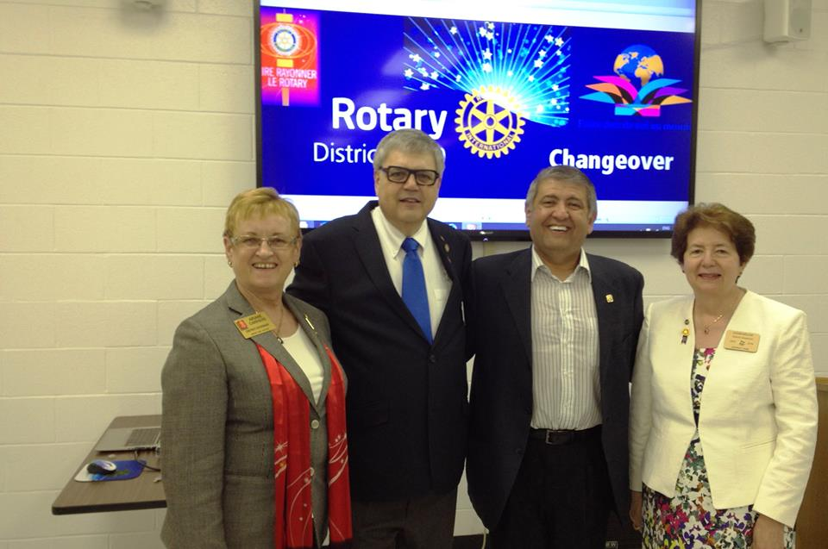
District Conference 2022 provides your organization opportunities before, during and after the conference. Be there where the action is! Meet attendees face-to-face or virtually, send your signage and material to promote your brand and services, supply banner ads or video to attract traffic from our district website to yours, partner on social media campaigns… we can help you reach out.

ONLINE PACKAGES

Website

Sponsorship has many advantages including exposure on the Rotary District 7040 website. Most sponsorship packages include a listing or logo with link to your website.

Display advertising presents the opportunity to promote your business to the community by partnering with our Rotary clubs within your geographic area. These ads are displayed on the district’s website for an entire year (July 2021 – June 2022). Pricing for the year is only $300.

Visitors to the District 7040 website are members and friends of local clubs within a close geographical area, as well as service-oriented individuals looking for a way to get involved with their community. The demographic is typically 35 – 65 year-olds with above average disposal income; providing a choice and localized audience for many sponsors and advertisers. This makes https://rotary7040.com/ an ideal site for small businesses offering products and services in the area. Since 100% of the advertising revenue goes back to our district, your investment in promoting your organization is also an investment in the community.

• Benefit from valuable visibility in your local area
• Sponsor mental health care and support Rotary in your community
• Enhance your public image and brand

In Conference

District Conference 2022- Reaching Out provides opportunities for sponsors to have direct and meaningful exposure to hybrid conference attendees prior to, during and even after the conference. There are many options to customize your partnership with this annual Rotary

Social Media

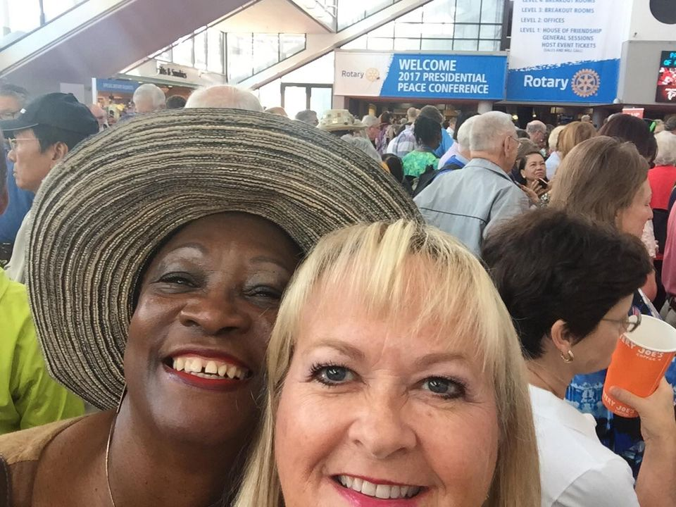
District Conference 2022- Reaching Out can serve to engage not just Rotarians (and Rotaractors, who are 18 – 30 year-olds) and the public at large, but your client base as well, with a wealth of information. We will encourage select sponsors for relevant social media content and leverage the platform to position District Conference 2022- Reaching Out and your organization as valuable partners to the local and global philanthropic efforts of Rotary.

Additionally, sponsor video and audio features and interviews, posted to both our social media platform and our partners, will help select package sponsorships realize an opportunity to and inform their followers of the importance and benefits of proper mental health care. to the social consciousness of their organization. An opportunity to create awareness as well as positively position your organization.

Social Media Exposure
Rotary District 7040 has experienced a strong growth in its social media in recent years. In doing so, we’ve been able to reach deeper and wider through Ottawa and the surrounding region.
A structured social media plan will start well in advance of the conference, picking up momentum just prior to and during the event, with ongoing posts afterwards, highlighting key speakers and conference take-aways. The importance of mental health awareness and promoting well-being deserves a concerted effort to promote relevant information that goes far beyond the conference itself.

SOCIAL MEDIA MIX
Facebook Followers - 2,126 Facebook Likes 1,630
Twitter Followers – 2,144 Total Tweets 5,074
Rotary District Member Database – 75 Clubs and 1700 members

Sponsorship Levels
- Presenting Sponsor  - (Quantity 1)  - Cost: $5,000  SOLD | District Conference 2022- Reaching Out recognizes the contribution of those helping to make this event happen. This is an opportunity for a key sponsor to take a leadership position and help shape the messaging. Your organization can position itself with a prominent role in the conference and gain prestige for presenting this multi day event.  - Recognition in all media, print, radio, web, social media articles that your organization presents this Conference (e.g. Rotary District Conference 2022 – Reaching Out presented by ‘Your Organization Name’)  - Signage at the conference  - Reach each attendee with collateral in conference registration package / in-app promotion  - Welcome attendees at specific plenaries and sessions  - Booth set up for promotional handouts at the conference  - Specific messaging from your organization to our District membership base via email and social media (NB Emails will be sent to all Rotarians in the district, whether they attend the conference or not, by Rotary District office via ClubRunner software.)
- Entertainment Sponsor  - (Quantity 1)  - Cost: $500  SOLD | Featured entertainer Justin ‘Jah'kota’ Holness, Owner/Founder of TR1BE Music  - Display signage with sponsor logos around the main stage  - Recognition in all print media, radio, web, and social media  - Booth set up for promotional handouts at the conference  - Reach each attendee with collateral in registration package / in-app promotion
- Session Sponsor  - (Quantity 9)  - Cost: $500 per session  FEW REMAINING | #1: Wellness in a Box: Rotaract Initiative & Panic, Anxiety and Stress Support Kit (PASS)  The focus of this initiative is: Depression awareness; suicide prevention; resilience building; stigma reduction.  #2: How do I know that I need help or someone else needs help, and what should I do about it?  This will be a two-person panel on Mental Health First Aid.  #3: Interactive Problem Solving  Interactive Problem Solving. This session will break up into smaller groups.  #4: Intuitive Eating  Intuitive eating allows you to replace automatic thoughts and reactions about food and eating with more conscious choices.  #5: Panel  Global View of Rotary Mental Health Initiatives.  #6: Anti-Bullying  CEO of No Time for That  #7: Closing Plenary  Awards, Citations, Covid Angel Awards, Promotion of Conference 2023, Promotion of International Conference District Governor Fay Campbell Closing Remarks  #8: Indigenous Youth and Mental Well-Being  Covid Impact, Discovery of Mass Graves at Residential Schools, How can Rotary help.  #9 Saturday Dinner  National Anthems, Invocation, In memoriam**, Dinner, Keynote, DG Remarks, Paul Harris Awards for key figures in the fight against Covid-19  Sponsoring either of these sessions provides:  - Display signage with sponsor logos at the conference  - Recognition in all print media, radio, web, social media promotions.  - Reach each attendee with your collateral in registration package / in-app promotion

Sponsorship Types
Sponsors are requested to indicate how they will contribute to the success of the conference in one of the following ways:
- Providing a financial donation in exchange for the appropriate recognition
- Other
* The sponsor is requested to provide an estimated value for the total proposed sponsorship value.

Terms and Conditions
- Sponsor will be asked to sign a letter of agreement defining the sponsorship arrangements.
- Provision of Cash or in-kind donations will be negotiated with each sponsor and defined in the letter of agreement.
- Full sponsorship cash contribution required at time of signing.

Selection Criteria
The selection of the limited quantity sponsorships will be based on the best value to the conference. Best value will be based on the quality of the sponsorship or product provided. District Conference 2022 – Reaching Out reserves the right to adjust sponsorship levels to meet specific needs or requests.

ROTARY DISTRICT 7040 CONFERENCE 2022 SPONSORSHIP AGREEMENT
COMPANY NAME: | d |  | PHONE NUMBER:
COMPANY ADDRESS: |  |  | CITY, POSTAL CODE:
CONTACT NAME:  TITLE: |  |  | SIGNATURE:
Level of Sponsorship  _____________________ |  | Type of Sponsorship  Cash  In-Kind  Combination Cash and In Kind  Other (describe below) |  |  |  | Estimated total value of Sponsorship  Cash:  In-Kind:  Other:  Total:

duties PERFORMED / responsibilities
Description of Sponsorship – Cash, In-Kind, or other

SKILLS |  |  |  |  | EQUIPMENT USED
Additional Information or Special Requests
Please return all sponsorship proposals to rotary@dwightbrown.com, or contact us directly at 613-769-4800.
___________________________________________________________________________________
Rotary District 7040 District Conference - May 4-7, 2022
www.Rotary7040.com

