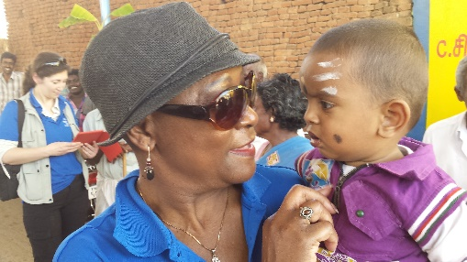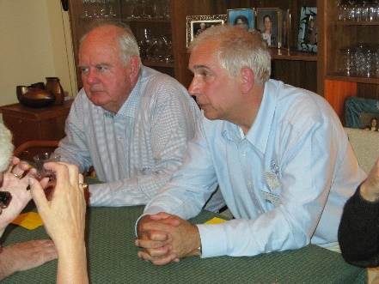-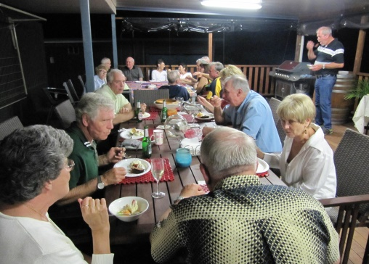

**Rotary Friendship Exchange**

Participants take part in reciprocal exchanges, usually during the same year. Hosting and visiting one another forge friendships that last a lifetime. It is a chance to genuinely experience another culture first hand by living and sharing in each other’s homes.

**What are the benefits?**

* Broaden international understanding
* Explore a specific profession or job in a different context
* Build enduring friendships
* Establish a foundation for peace and service
* Gain opportunities for active project involvement and support
* Learn about a region’s people, food, languages, customs, and history
* Find partners for grants

**Rotary District 7040**

Rotarian Don Hall from Australia in Canada with Rotarian Mike Goss

#### Life-time Friendships

The District Friendship Exchange Chair is responsible for contacting other Friendship Exchange District Chairs from around the world to find out which districts are interested in arranging exchanges and to coordinate all specific details such as location, length of stay, and number of participants.

Fay Campbell on Exchange to Chennai India 2016 “One of the great Experiences of my Life”

www.rotary.org/connections

District Friendship Exchange Chair: Fay Campbell

[faycampbell21@gmail.com](mailto:faycampbell21@gmail.com)

613-523-2111

cell 613-859-5971

**Go on a Rotary Friendship Exchange….**

**You’re Never Just a Tourist!**



District Friendship Exchange Chair: Fay Campbell

[Faycampbell21@gmail.com](mailto:Faycampbell21@gmail.com)

613-523-2111 cell 613-859-5971

# Friendship Exchange

**A Typical Day on Exchange**

Exchanges incorporate a wide array of social events, local activities, Rotary gatherings, and leisure time. Each itinerary is different, but the following experiences can all be part of an exchange: touring scenic areas and historical sites, visiting schools, civic institutions, malls, bazaars, restaurants, zoos, and businesses, exploring churches, temples, mosques, synagogues, and other places of worship, museums, and galleries.

**Where is the Next Exchange?**

Contacts have been made with Districts in Southern Africa, Europe and South America.

**Questions?**

Contact Chair: Fay Campbell [faycampbell21@gmail.com](mailto:faycampbell21@gmail.com)

Members of Committee & past friendship exchange members:

PDG Katie Burke

[brkcornwall@gmail.com](mailto:brkcornwall@gmail.com)

Anna VanAdrichem-Rochon [anna.varochon@gmail.com](mailto:anna.varochon@gmail.com)

Australian BBQ Exchange 2012

# Why go on an Exchange?

An exchange can be the starting point for long-term international relationships between clubs and participants. Participants often use their new friendships as the basis for partnering on service projects that create lasting change.

**Cultural Immersion**

Exchanges also offer unique chances for cultural immersion and interchange. Some incorporate educational opportunities for professionals of any age to build global understanding and boost vocational and leadership skills.

“The best way to learn about a person’s life, culture, and challenges is by living and participating in their daily life. As a result of my exchange in India, I learned that people around the world have the same desire - a secure life for ourselves and our children.”

Anna Van Adrichem-Rochon Exchange leader to India 3131 in 2010

# Who goes on Exchange?

Friendship Exchange participants may travel as an individual or as couples. Groups may include Rotary members and non-member partners.

Participants are responsible for their own travel, insurance, and personal spending. Hosts are expected to provide housing, meals and sightseeing opportunities.

A team leader will be selected by the team members. Generally the most senior Rotarian with past experience with exchanges or past District Governors will be the first choice.

Applications to be part of an exchange team should be forwarded to the RFE committee chair.

#### Rotary Friendship Exchange